Attention-Circuits-Control Laboratory ([www.attention-circuits-control.org](http://www.attention-circuits-control.org))

**For more information on how Quaddles are generated and may be used:**

Watson, MR., Voloh, B**.,** Naghizadeh, M., Womelsdorf, T., (2018) “Quaddles: A multidimensional 3D object set with parametrically-controlled and customizable features” *Behav Res Methods.*

**Website guide**: <http://accl.psy.vanderbilt.edu/resources/analysis-tools/3d-image-material/>

**Brief instructions on how to use scripts**: <http://accl.psy.vanderbilt.edu/quaddlegenerator-brief-instructions/>

**Scripts, objects and in depth manual available on github**: <https://github.com/att-circ-contrl/Quaddles-Gen>

**Creating Symmetrical Quaddles (5th Edition)  
Milad Naghizadeh 2018**

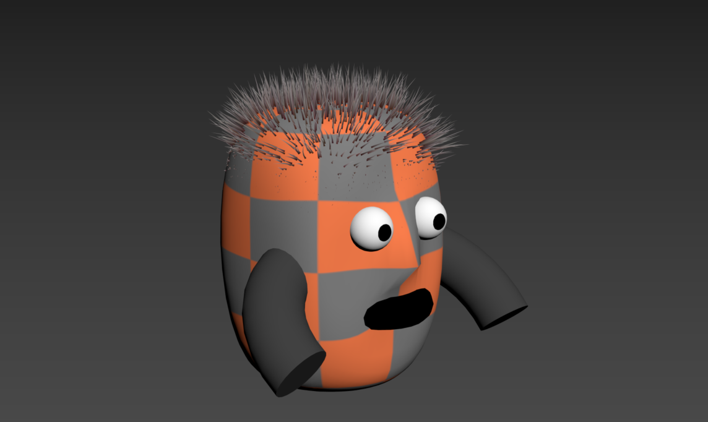

**Legend**

**Part 1: Installing and using 3ds Max**

**Part 2: Creating Objects Manually**

**Part 3: Creating Objects Using Existing Scripts**

**Part 4: Main Script Outline**

**Part 5: Functions List**

**Part 6: Other Scripts**

**Part 1: Installing and using 3ds Max**

First thing you need to do is download and install Autodesk® 3ds Max 2017. You can do this at <https://www.autodesk.com/education/free-software/3ds-max>. Alternatively you may google *“3ds max student license”* and it should be the first or second link.

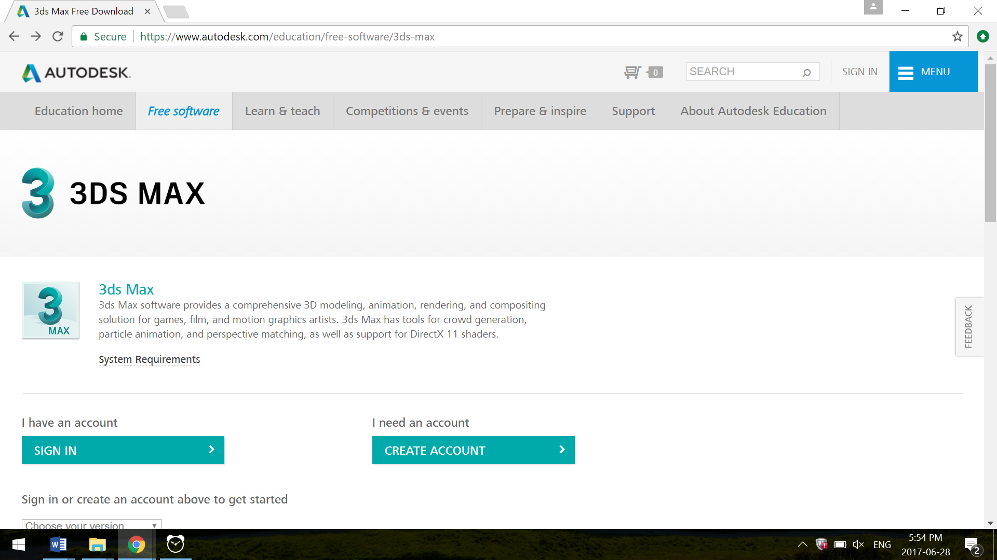

You need to create an account or sign in to an existing account. If you are affiliated with an educational institution and not intending to use the software for commercial reasons you will be able to install the software on two personal devices.



If you are creating an account for the first time, you will need to provide an email address and will need to access that email to activate the account. You will be required to indicate your educational institution and your role in it.

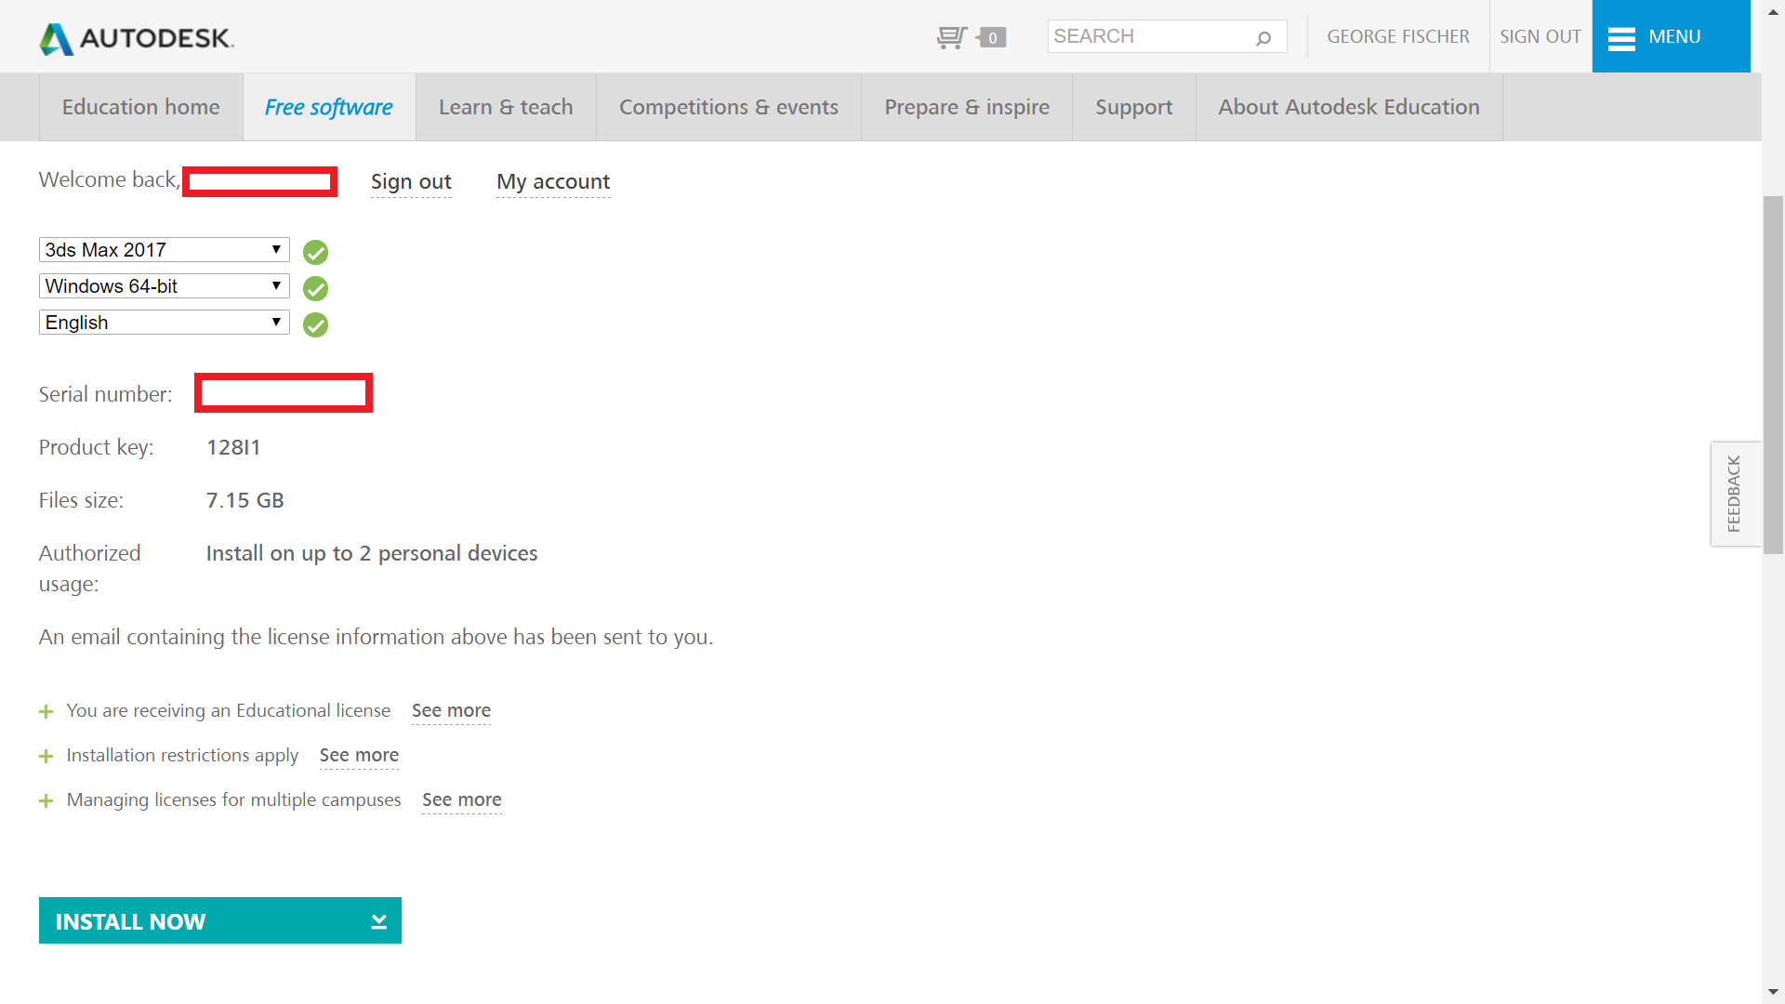

After creating an account you’ll be able to specify **3ds Max 2017**, your O.S., language and you will be ready to install. Make sure to record your serial number. Click “INSTALL NOW” and you’ll be ready to rumble!

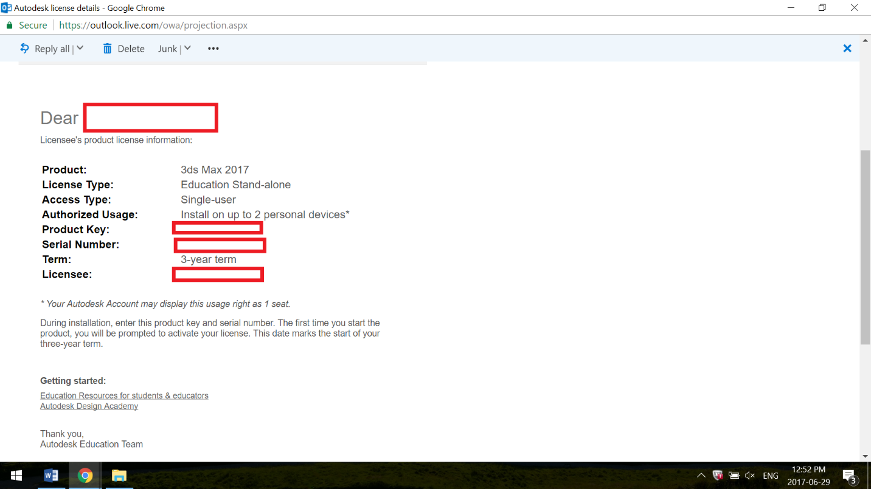

Autodesk will also send you an email indicating your **product key, and serial number.**

At this point, after you’ve downloaded the installer, all you need to do is follow the on-screen instructions, and type in the **product key and/or serial number** when prompted.

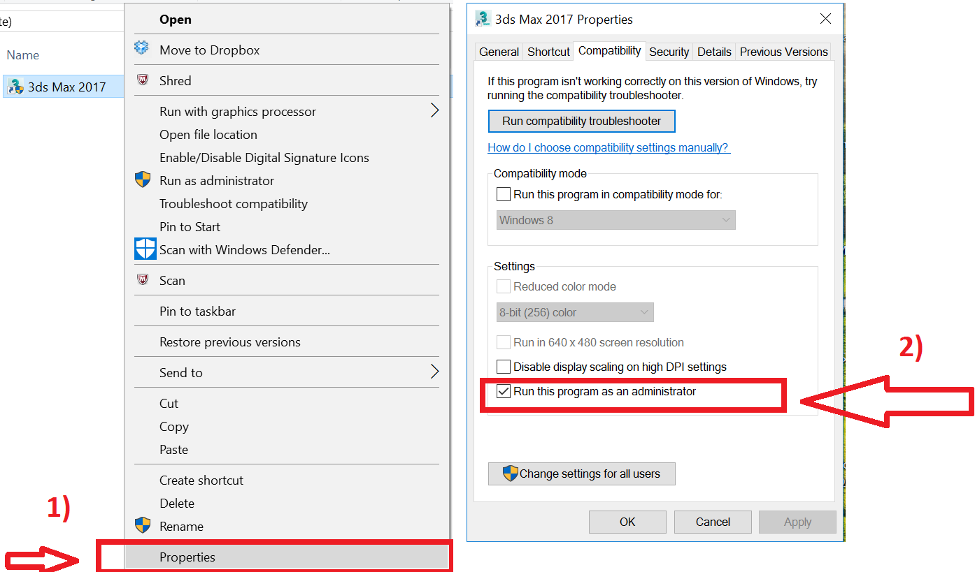

**Tip:** It may cause you less headache later on so it’s a good idea to set the default for the program to be run as administrator.  
Right click on 3ds Max🡪click properties 🡪 Open compatibility tab🡪 Make sure “Run as administrator” is checked

**Opening Software**

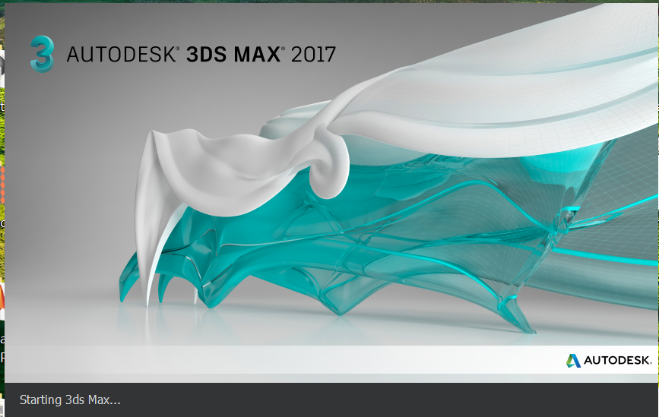

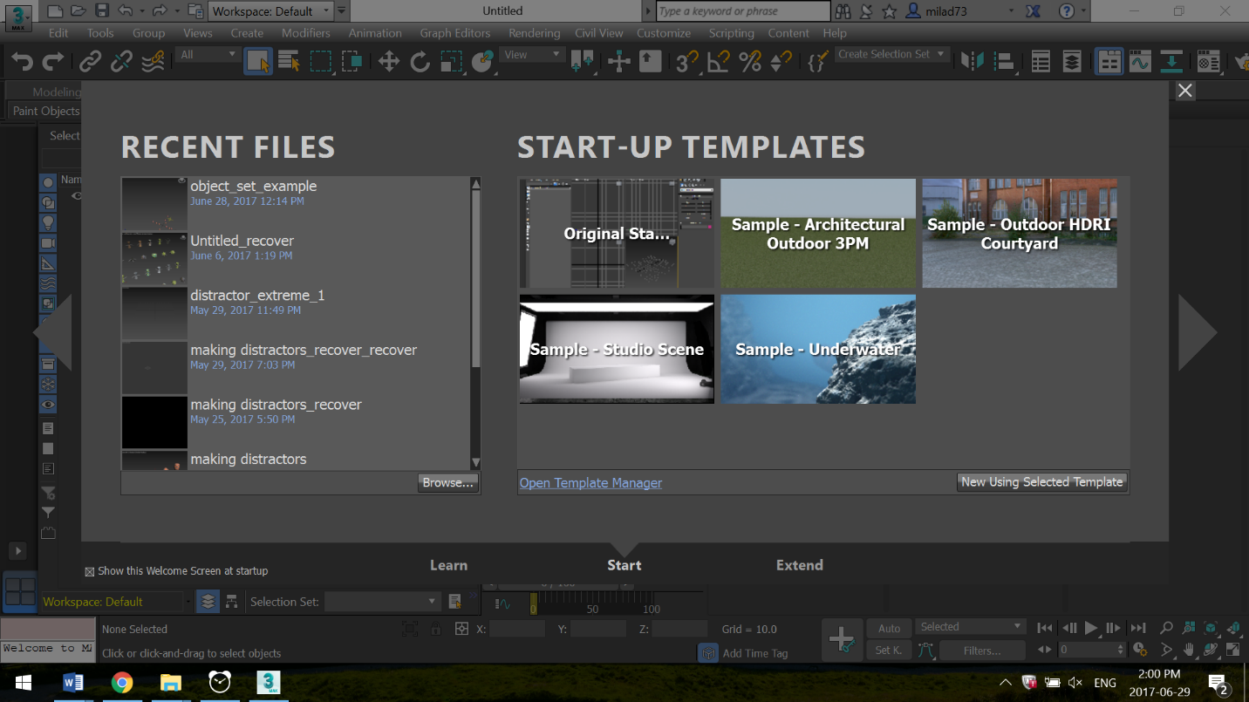

When you first start up the software, you’ll have the option of choosing a number of start-up templates. Choose **Original.**

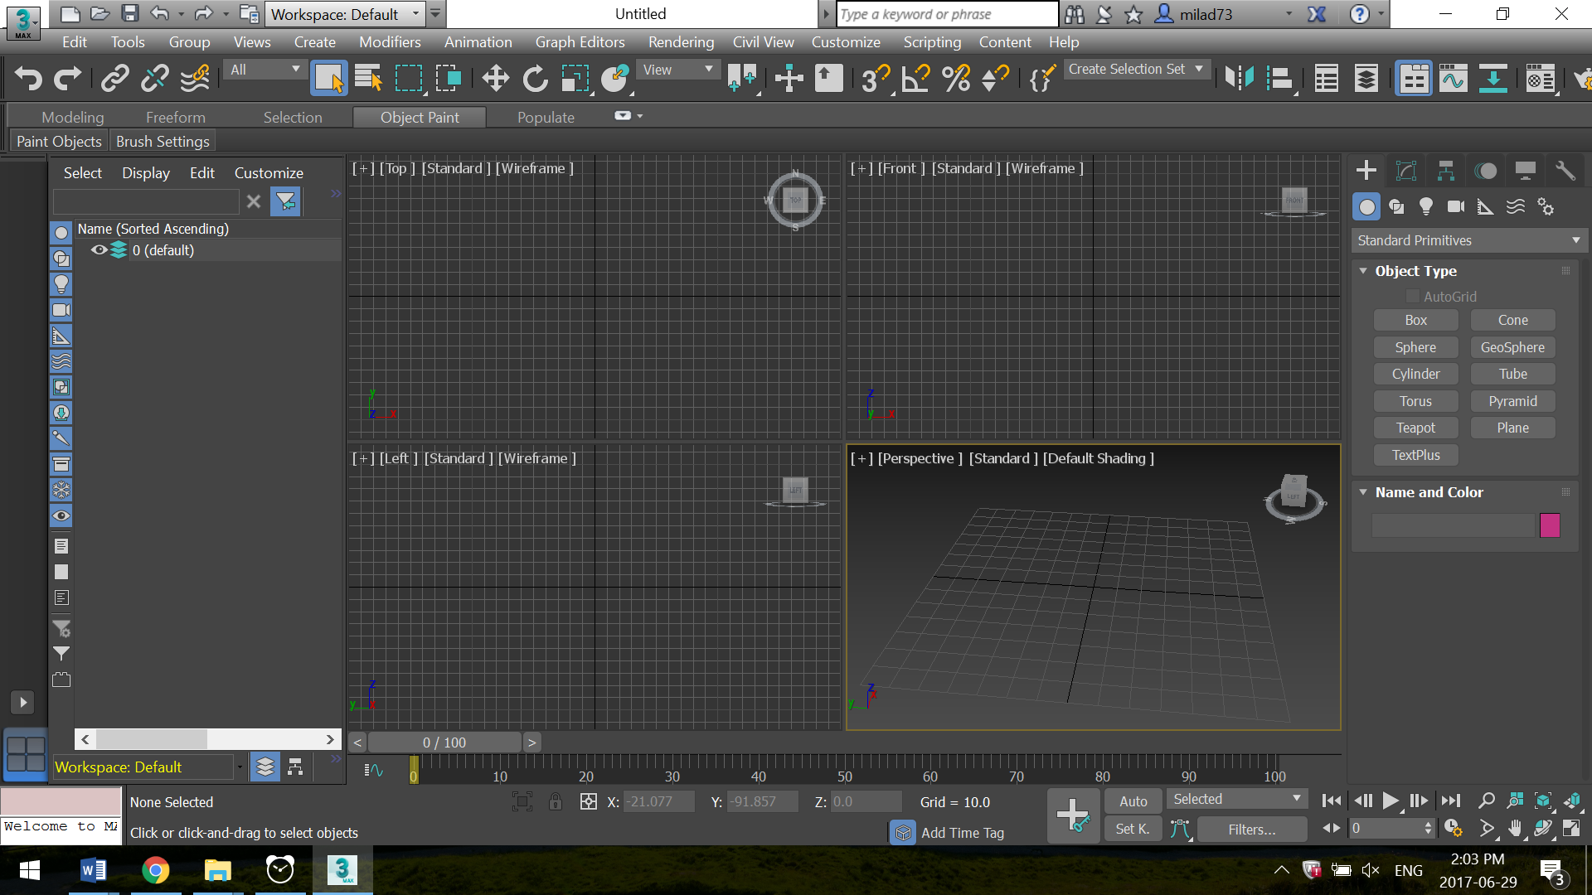

You’ll be greeted with a standard viewport such as this, and have four different perspective views. Clicking any one of these perspective views and pressing **Alt+W** will make that window take up the whole screen.

**Getting your feet wet**Play around with the tools and get familiarized with the UI. It’s recommended that if you’re a beginner to try out some standard tutorials freely available online such as this one where you make a model helmet;

<https://knowledge.autodesk.com/support/3ds-max/getting-started/caas/CloudHelp/cloudhelp/2015/ENU/3DSMax-Tutorial/files/GUID-39B2F89C-ED74-45F9-8B5F-0274DC20C3FD-htm.html>

Other introductory tutorials;

<https://knowledge.autodesk.com/support/3ds-max/getting-started?sort=score>

**Using a Mouse**

Using a mouse will make using the software a lot easier. Using the following shortcuts makes it much easier to view objects from different perspectives

**Scroll wheel –** Using the scroll wheel you can zoom in and out

**Hold Alt + Push down on scroll wheel and move mouse –** Rotating view/perspective

**Push down scroll wheel and move mouse –** Drags and moves perspective from same angle

**Useful tip for Scripting and Debugging!**

Sometimes figuring out the right syntax to use to accomplish a particular task can be somewhat confusing. A useful solution I’ve found is to use the “MacroRecorder” in the MAXScript Listener

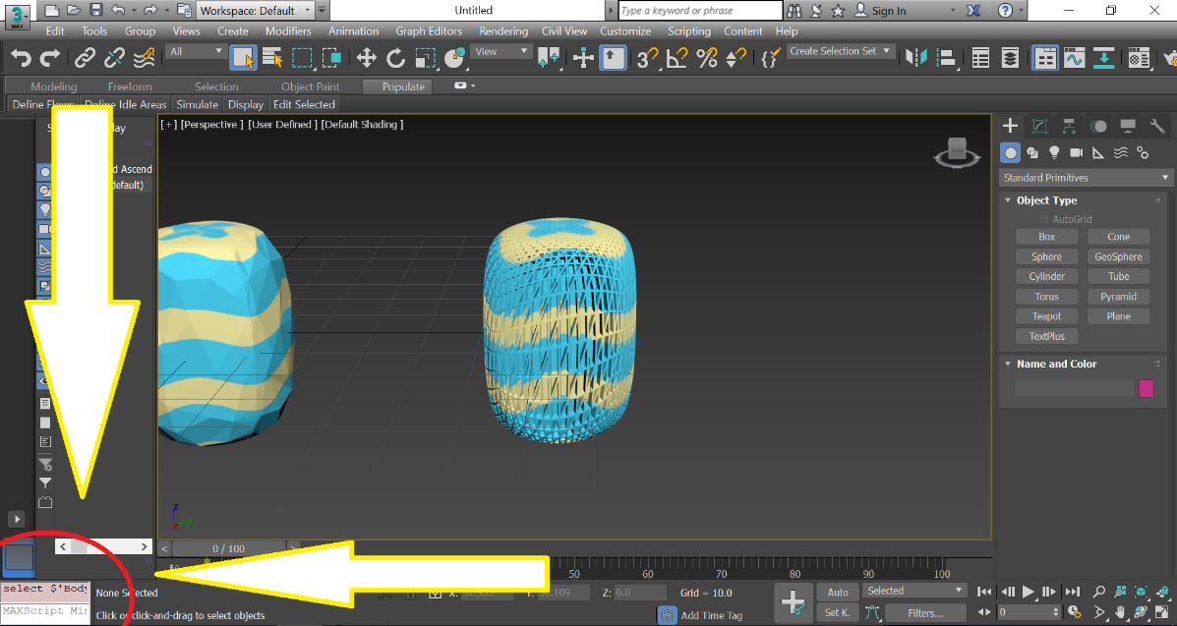

First you’ll need to open up the MaxScript Listener which is found at the bottom left corner of your screen. Just Right-click and click “*Open Listener Window”*

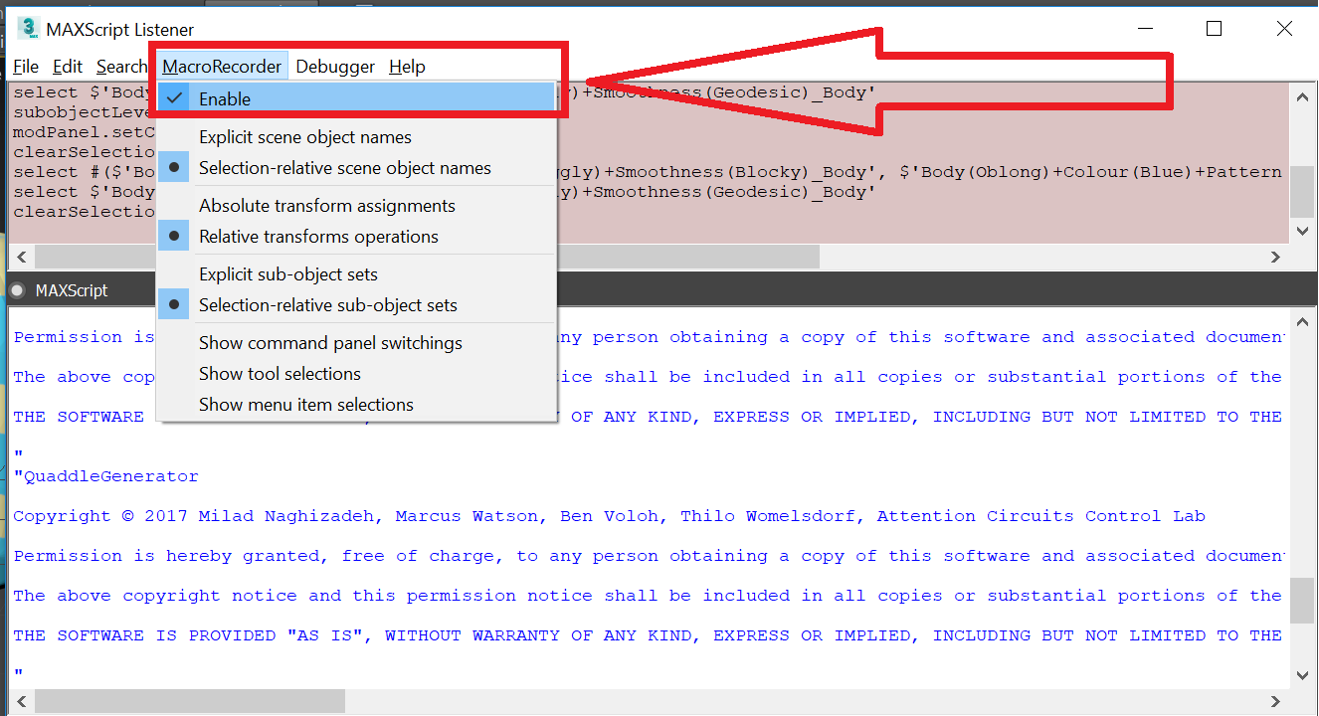

Once the “Listener window” is open, click MacroRecorder and make sure it’s Enabled.

Now any action you do in your window will be reflected in the equivalent code on the upper pink half of the window. For example, anytime you click something or transform an object, a line of code will appear which will tell you how you would be able to perform that very action in script.

**NOTE:** The MAXScript Listener is also very helpful for ***debugging***. Executed lines in script will show up here (in the bottom white half) along with any errors you may encounter. You may also input commands in the window as well.

**Other Shortcuts:**

**F4 –** Shows surface polygons on objects  
**M –** Brings up material editor window  
**f11 –** Brings up maxscript Listener window (important for debugging)  
**Ctrl+e –** Runs a Script that’s currently selected  
**G –** Shows and hides grid  
**Congratulations!** Now the real fun can begin and you can start your adventures in the world of 3D modeling.

**Part 2: Creating Objects manually**

Please note, that this section of the manual mostly covers how to create the basic set of 16 objects manually in 3ds max,

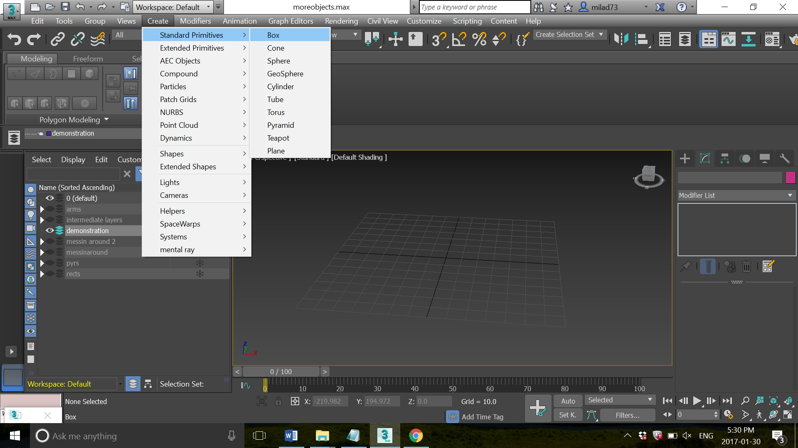

To start off, all objects are created as a rectangle with the same basic dimensions. Click Create🡪Standard Primitives🡪 Box

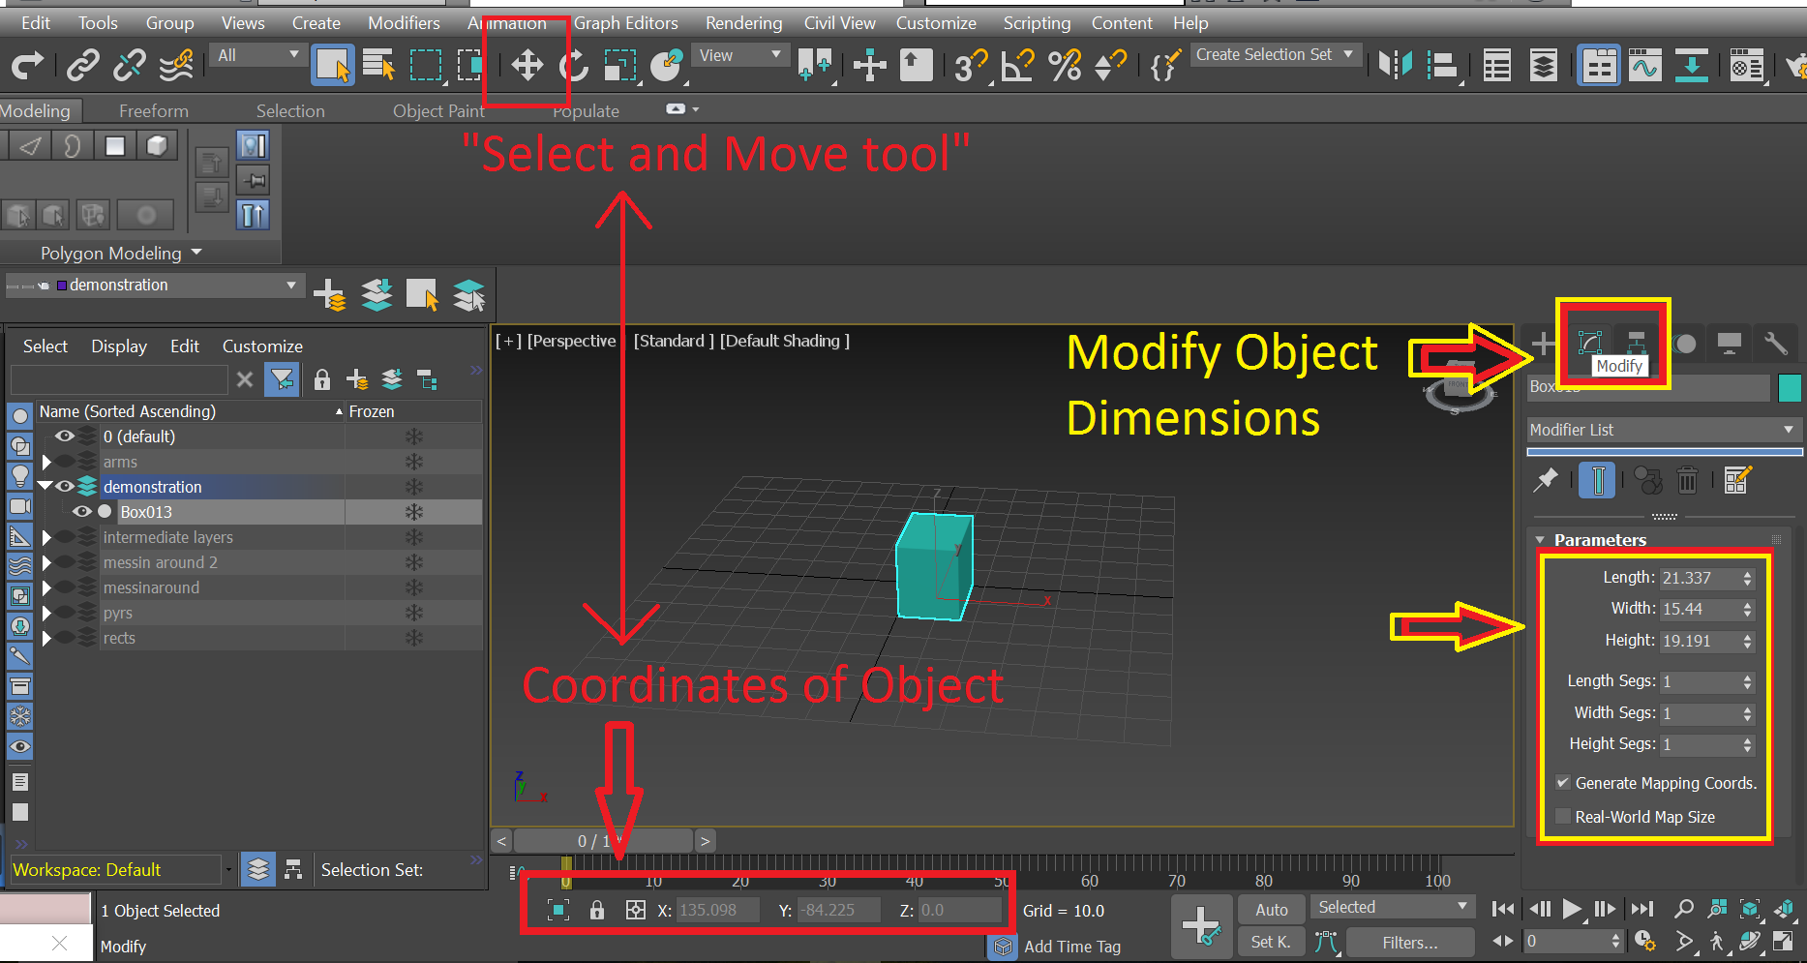

Use the curser to create the dimensions of the box. The box’s position on the grid can be set using the X,Y,Z coordinates at the bottom of the screen after selecting the “select and move” tool. (See icon below and red labels above).

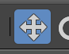

Similarly, the box’s length, width, height, and number of segments its divided into can be adjusted by accessing “Parameters” in the modify tab to the right of the screen (see yellow above). In our case, we created a 20x20x40 rectangle divided into 10x10x10 segments (note:Pressing f4 allows us to actually see these segments)

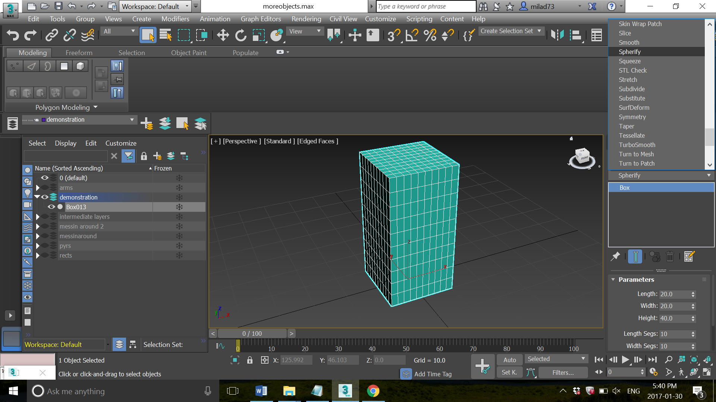

Clicking the modifier list, we add the “spherify” modifier to the object. This will allow us to create an object with a “puffy” look later, when we deform it into the shapes we want.

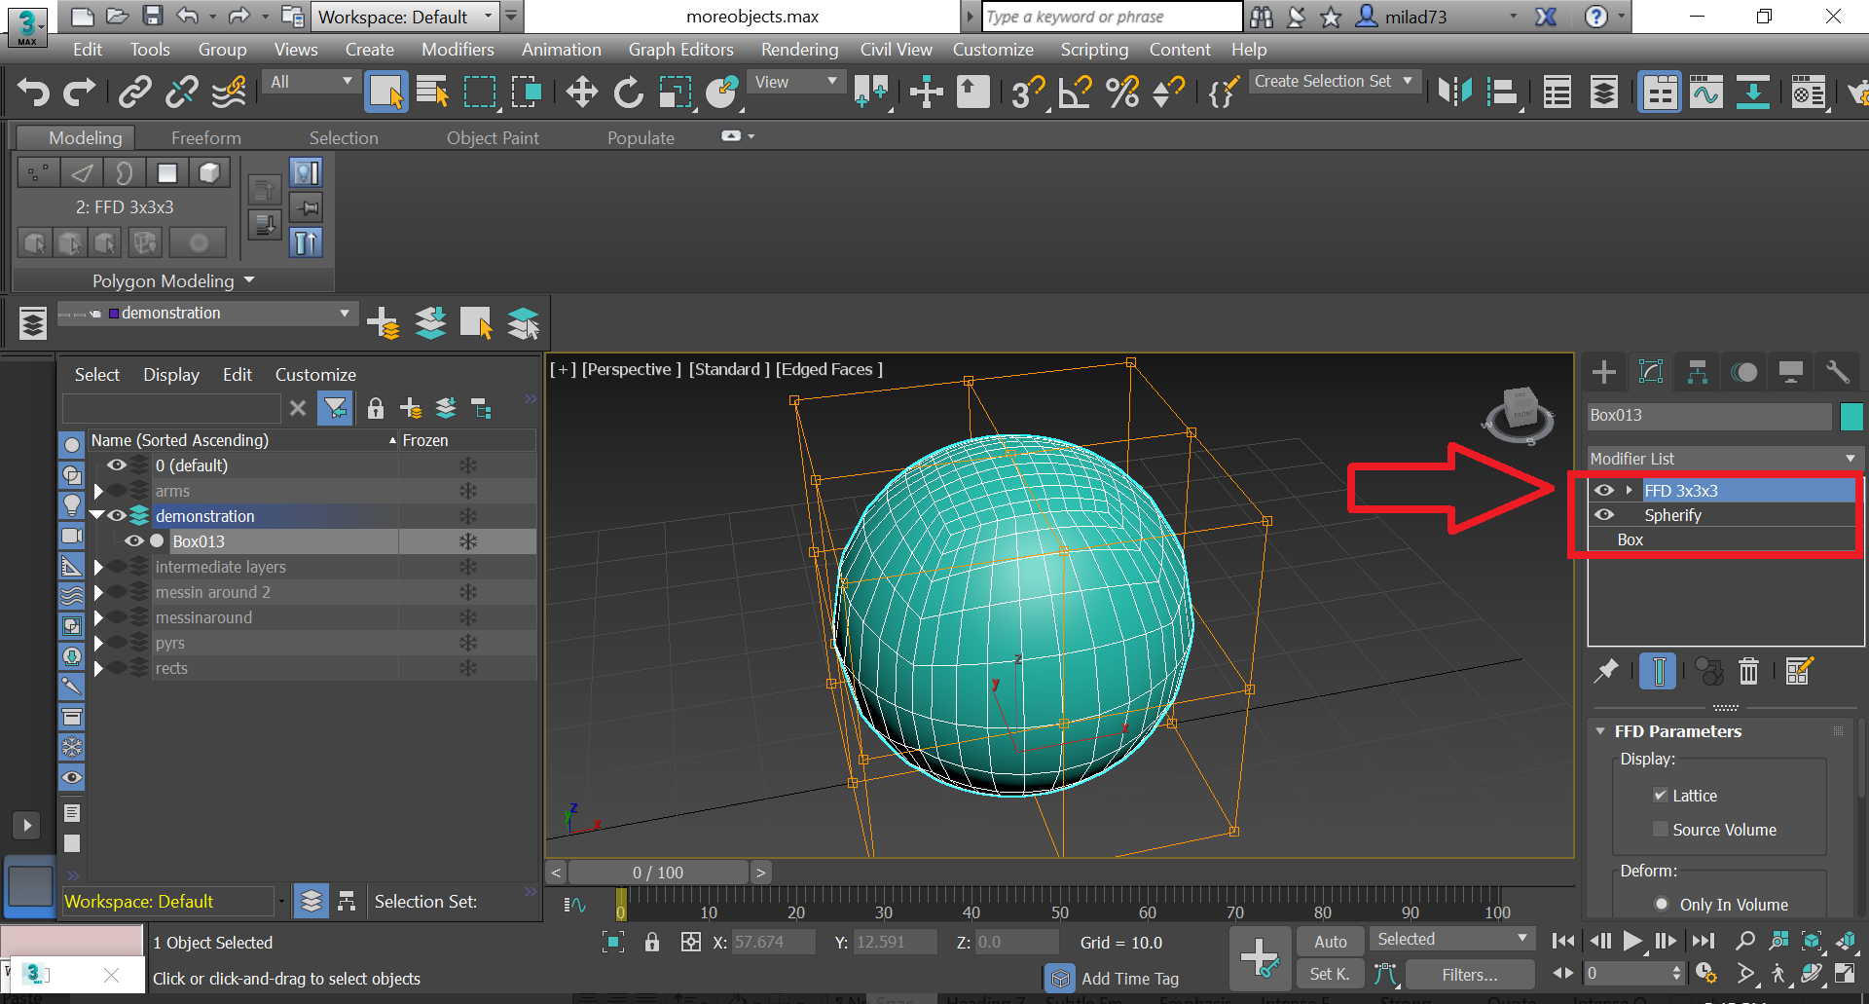

Using the same modifier list, we also add the “ffd_3x3x3” modifier (free form deformation modifier) to the sphere. At this point, creating the shape of the object body we want is merely a matter of moving these control points (for a detailed explanation of the deformations at the control points, see script functions).

**Note:** Other FFD modifiers exist as well which allow you to have more control points. Ffd_3x3x3 was used for all objects that we created.

To move control points, select the arrow next to “FFD 3x3x3”🡪 Select Control Points, and select the “select and move tool” 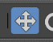. You should be able to manipulate each individual control point.

**Giving objects more smooth shape**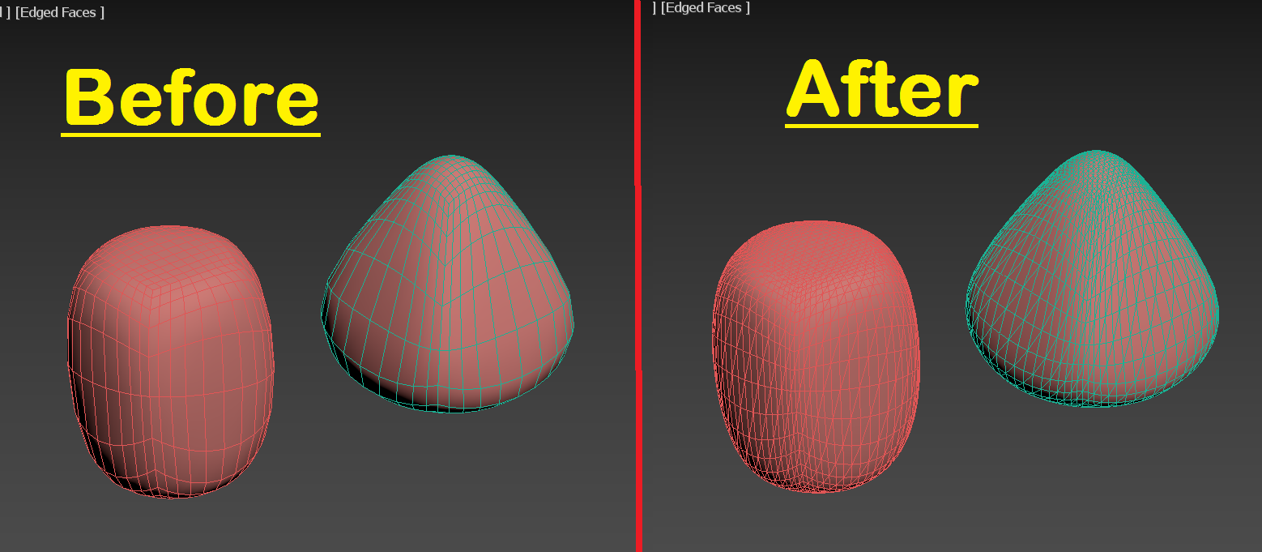

Adding the “**Tesselate”** modifier to our objects will smoothen our objects a bit, making them less jagged and rounded, increasing the polygon count in the process (see before and after above). Adding more polygons will make patterns apply to the objects in a slightly nicer way as well.

Keep in mind that whenever you add more polygons to a game object, more computational resources will be needed to render it in any software.

**NOTE:**If you are planning on making the objects wrinkly later on, it’s recommended you use the “**TurboSmooth**” modifier instead of **Tesselate**.

If you are making “Inwardly protruding” or “outwardly protruding” objects, then **no smoothing** should be applied

**Adding materials to objects**

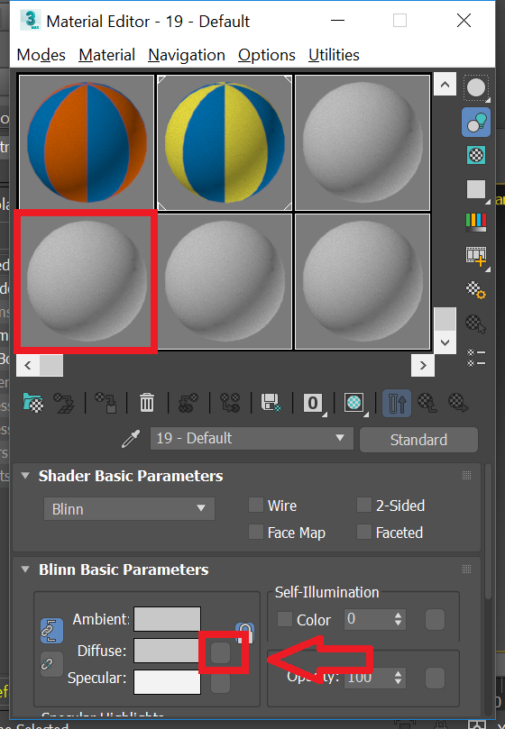Press “m” to bring up the default materials editer. Click on an empty sphere, and then the checkbox next to “Diffuse”. This will open up the material browser window.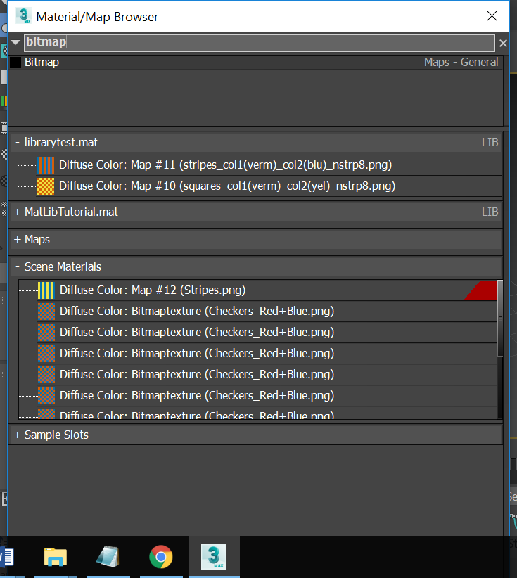

Type and search “bitmap” to open the following window.

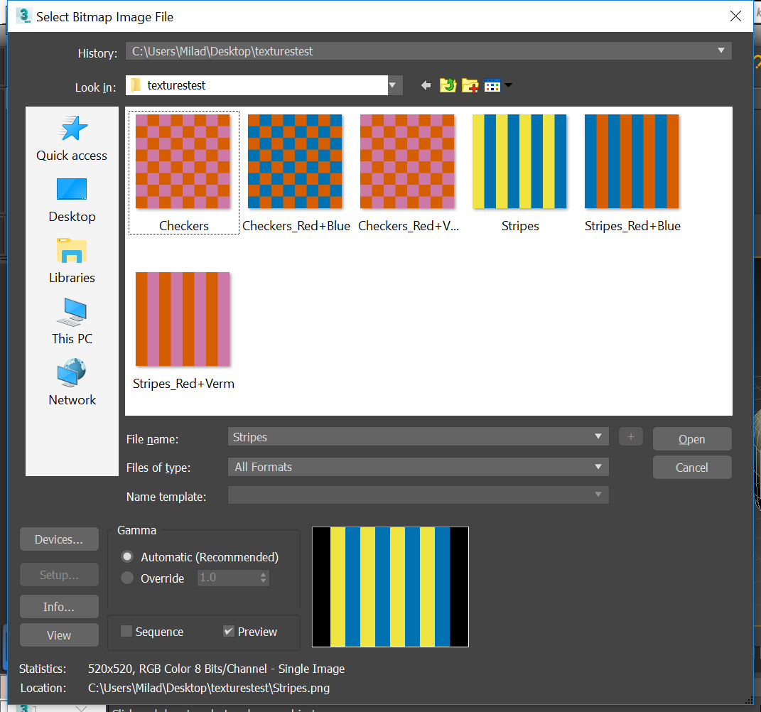

Here, you find the texture you want to add. Once it’s selected, it will appear on the material map editor. At this point, all you have to do now is drag the bitmaptexture from the sphere on the material editor onto the object surface you want to add it to.

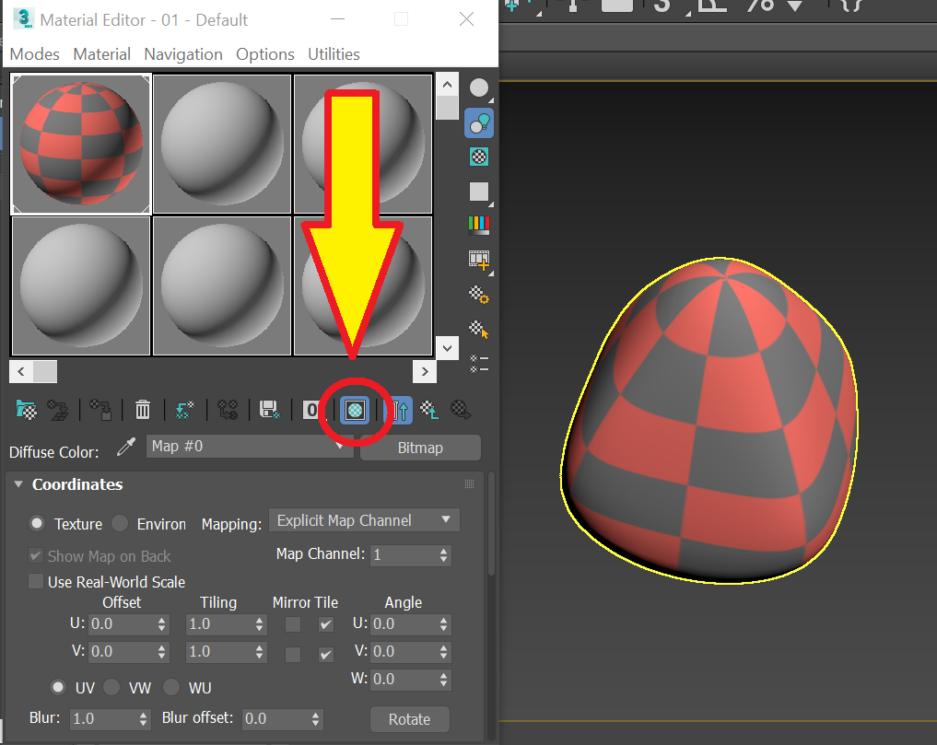

After applying the material to the object, make sure to click the **“Show material in viewport”** option 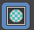 otherwise you won’t be able to see the textures that you’re working with.

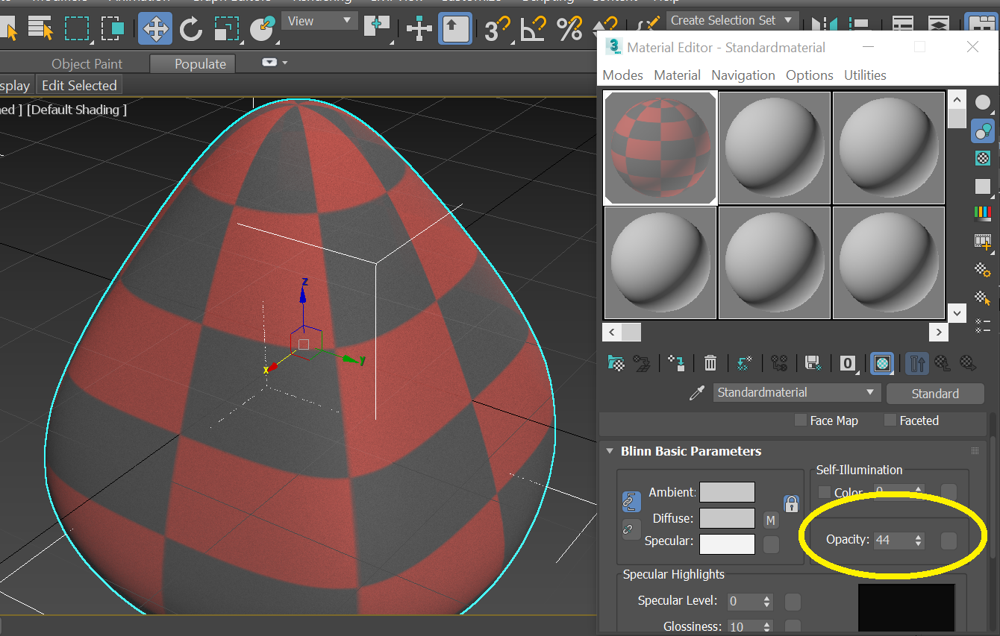

**NOTE:** You can also change the opacity of the object if you like in this drop down menu. Here it’s set to 44%

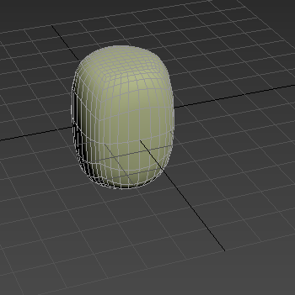

However, you may notice that the object at this point still appears to have no material added to it still. You will need to add the “UVW Map” modifier to the object, for the texture to appear. Again this can be added by accessing the modifier list in the modify tab.

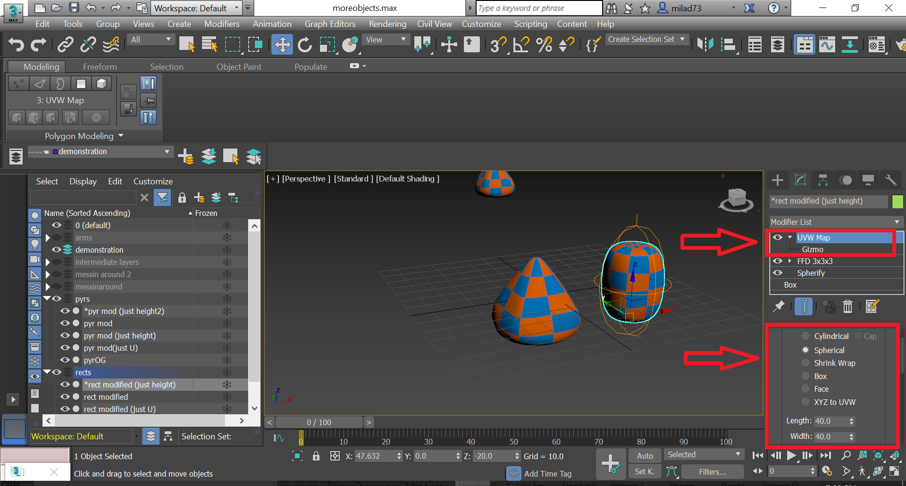

The mapping settings can be changed to ensure that the texture wraps the object in the way that you want it to. Depending on the type of pattern that you’re trying to apply, it can be very difficult to ensure it wraps around the object nicely. You may have to experiment around with different wrapping settings if you’re using a different pattern.

For the objects shown above for the oblong rectangular shape, ***Spherical*** mapping was used and for the pyramidal shape, ***Cylindrical*** mapping was used.

For the **Checkered Pattern,** the following UVW mapping dimensions were used.Length: *40*Width: *40*Height: *60*

For the **Diamond Pattern,** the following dimensions were used;   
Length: *40*Width: *40*Height: *100*

**NOTE:** These values may be subject to change in future iterations of object sets, or may be tweaked to optimize the use of alternative patterns (i.e. not Checkered or Diamond)

**Creating and adding Arms**

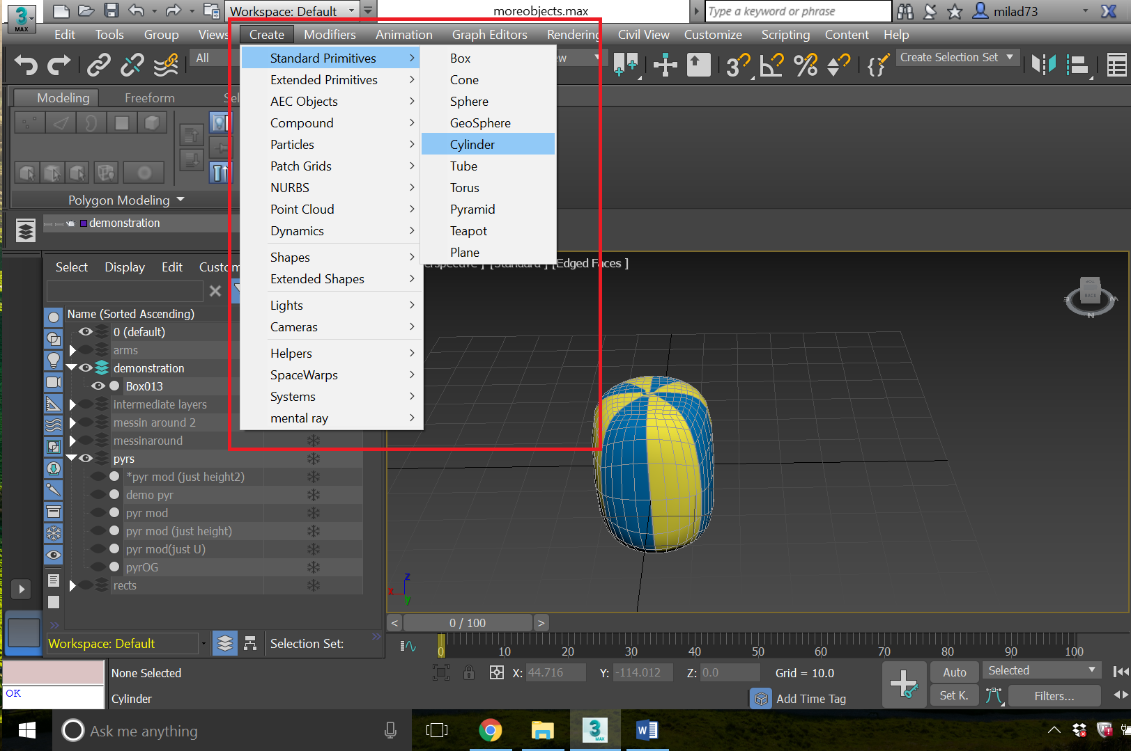

Click Create 🡪 Standard Primitives🡪Cylinder.

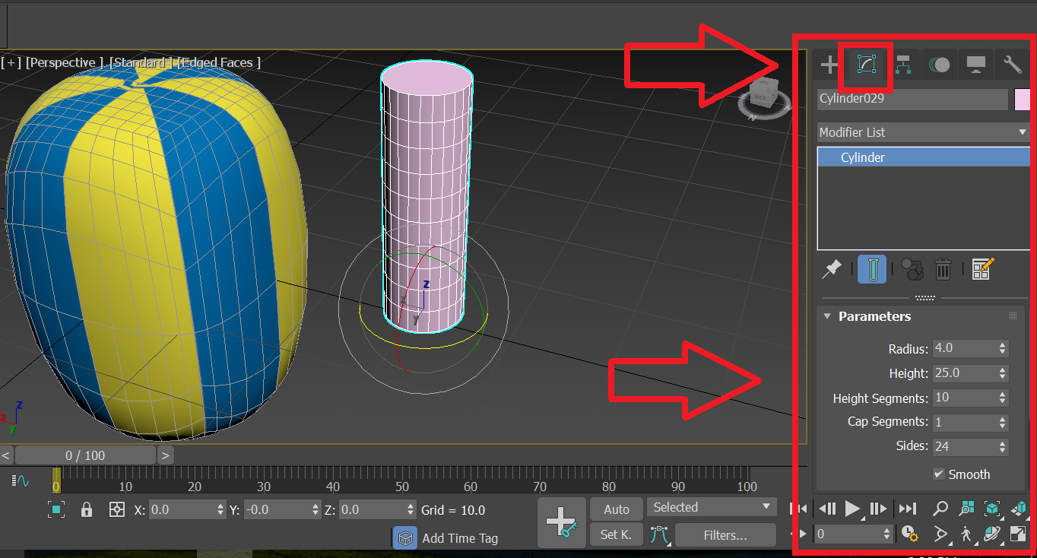

Similar to before, we can change the dimensions of the cylinder we just made by accessing “Parameters” in the “modify” tab. For our arms, they were of radius 4, height 25 and divided into 10 segments.

Note: Here we are using a cylindrical object as the arms. Alternatively, if you want to create *pointed* or *flared* arms, you may be able to do so by creating a cone instead. With the cone you’ll be able to set starting and end radius’s to suite your needs. Any and all other transformations that are applied to the “cylindrical arms” outlined here can be applied to the “conic arms” as well

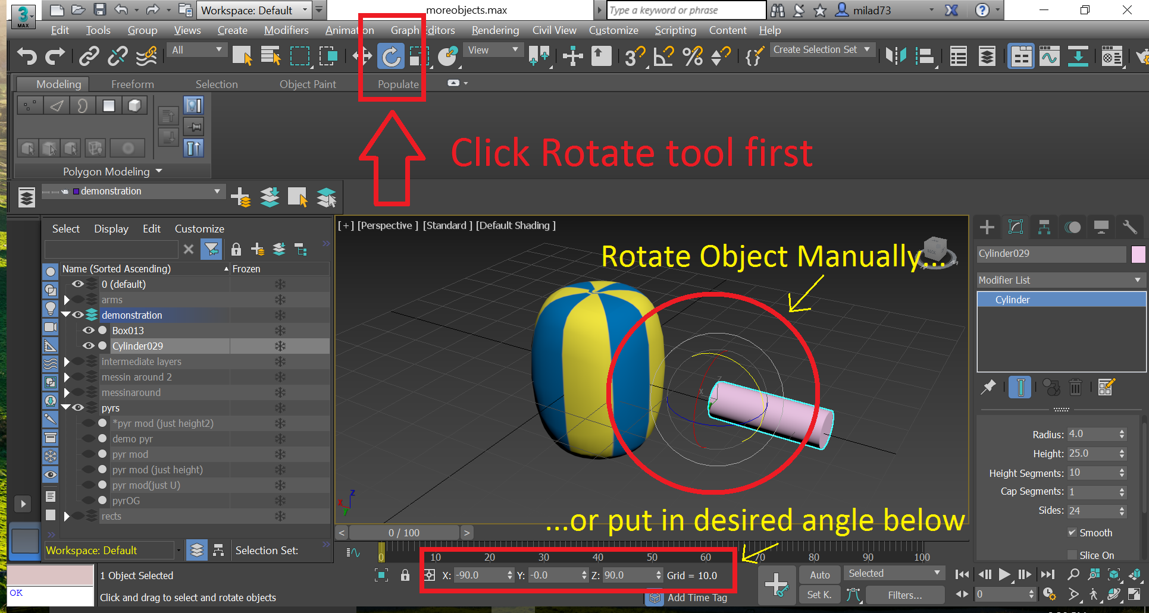

In order to have the correct orientation for the arm, we need to select the rotate tool, and then either change the orientation with the curser on the object or put in the desired orientation using the x, y, z angles on the bottom of the page.



By selecting the “select and move” tool, we can move the arm into the main body. Holding shift, whilst moving the arm will replicate the arm. Using the combination of both the “rotate” and “select and move” tools, we create 4 different arms which can be evenly positioned within the body of the object.

(Note: When we create copies of the original arm, a pop up window will appear asking how we want to make copies of the original object. It can help to make the copies “instances” of the original, in order to ensure that all modifiers added to the original arm will also be added to the other arms)

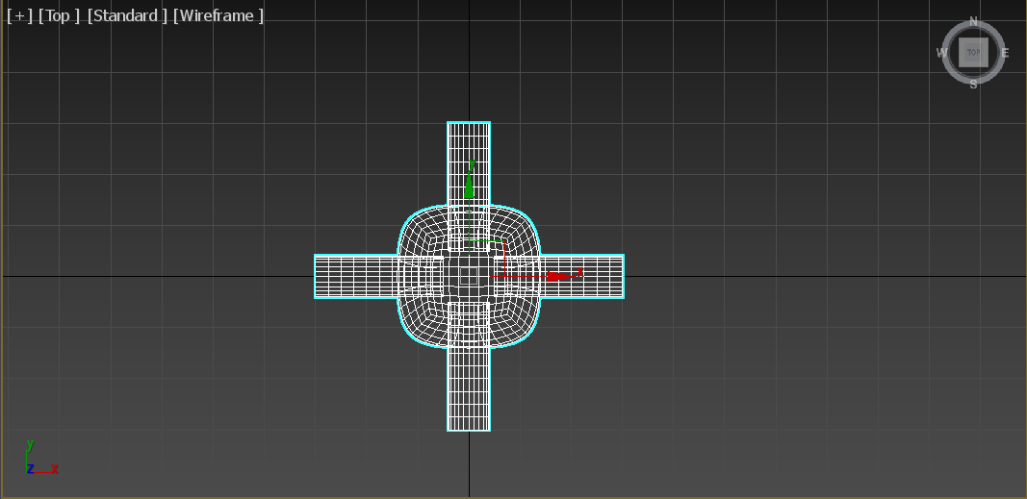

Using the “Top” viewport and Wireframe can help us evenly embed our arms. For our objects, we embed the arms in the body by 7 units.

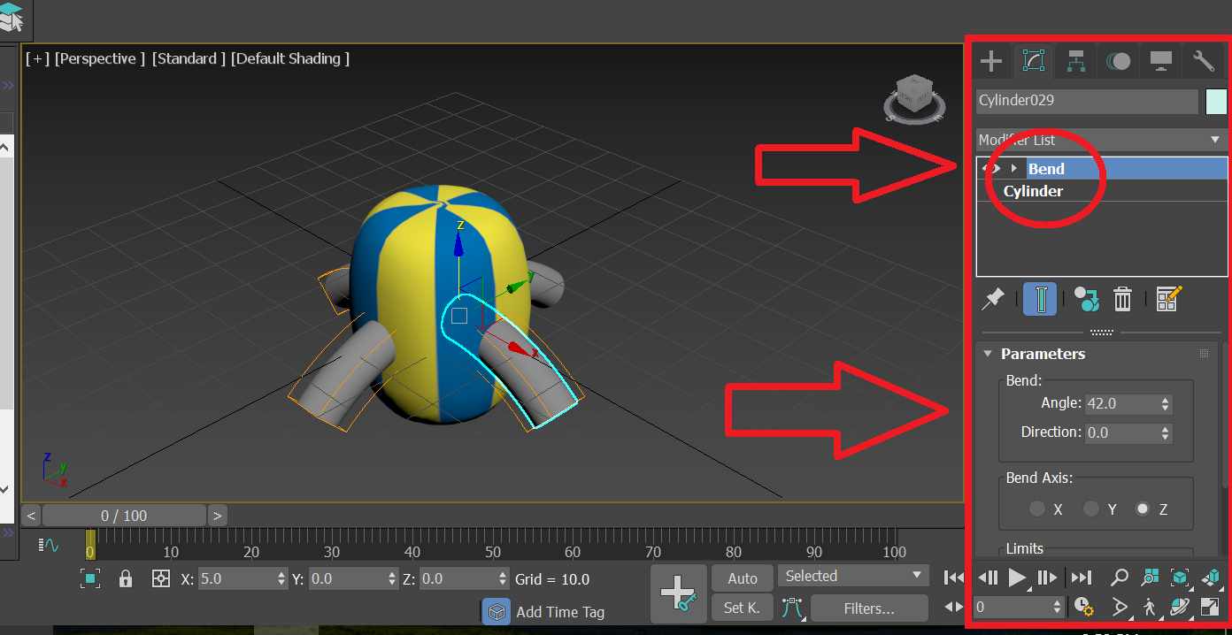

Similar to how we added, the spherify, ffd_3x3x3, and UVW_map modifiers to the body of the object before, we add a “bend” modifier to the arms. The desired angle we want can be set in the “Parameters” box. In our case we used a 42 degree bend in the z-axis; using a negative degree bend will bend the arms upwards.

**Grouping Objects**

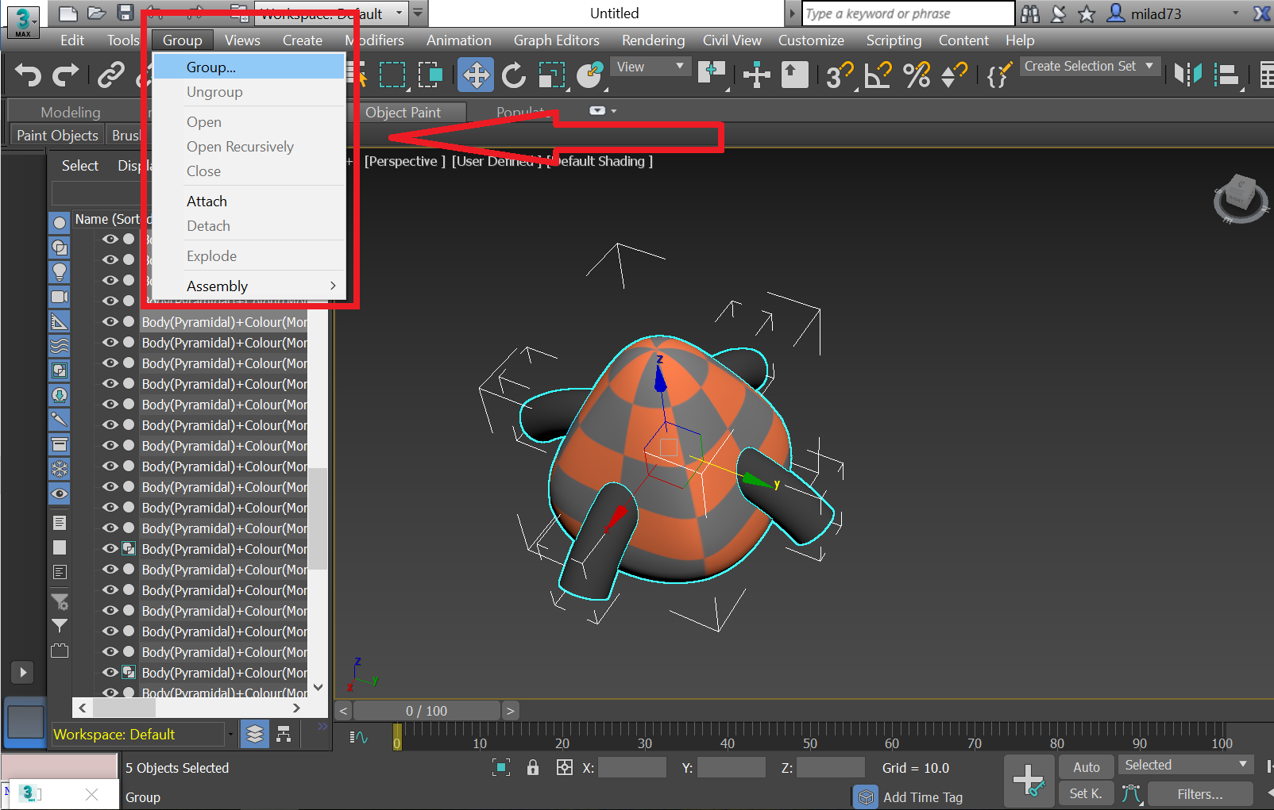

At this point, your object consists really of 4 separate objects. In order to group them, make sure that the body and all branches are selected and hit the **Group** tab 🡪 click Group

Note: In order to ungroup select object, click group 🡪 explode

**Exporting Objects**

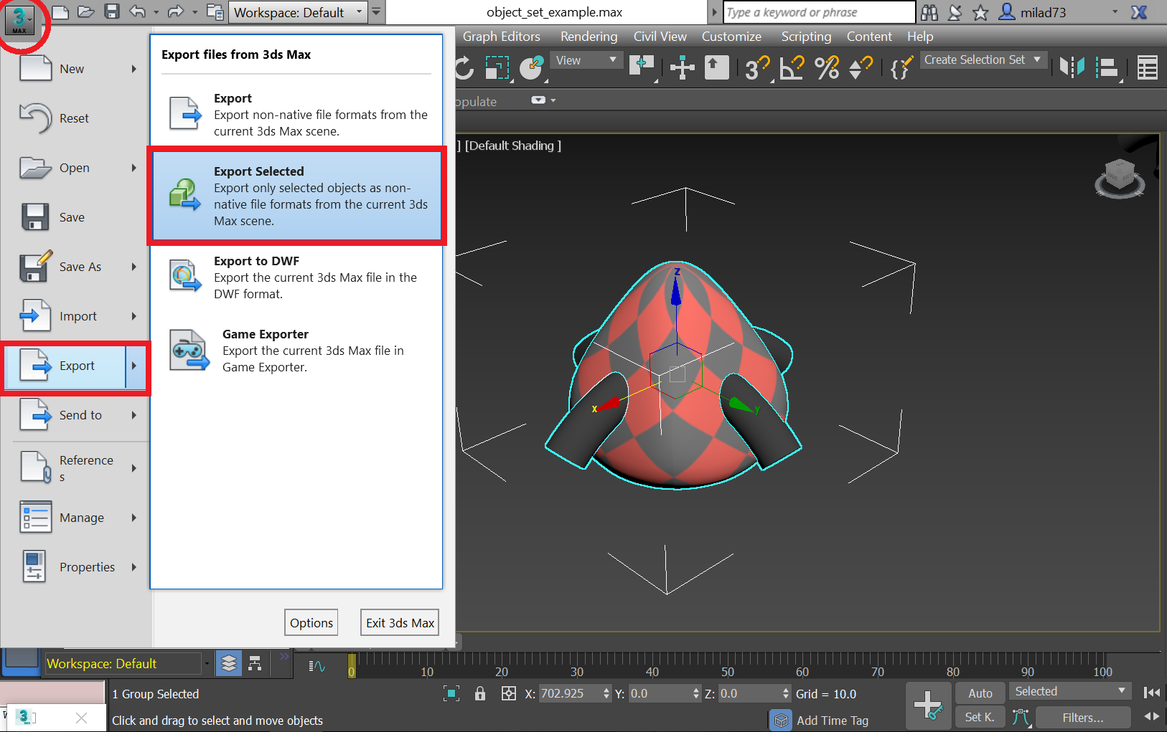

In order to export, first select the object that you want exported and click the 3ds Max icon at the top left  🡪 Click **Export 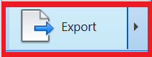 🡪** Select **Export Selected 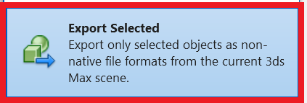.** You will then have to specify where you want the object saved and the kind of 3d object you want it to be. Typically if you want to use the objects for another game engine such as Unity, you should save the file as **.FBX**

**NOTE:** If you want to save the object as an .stl file for 3d printing, select export instead of “Export Selected”.

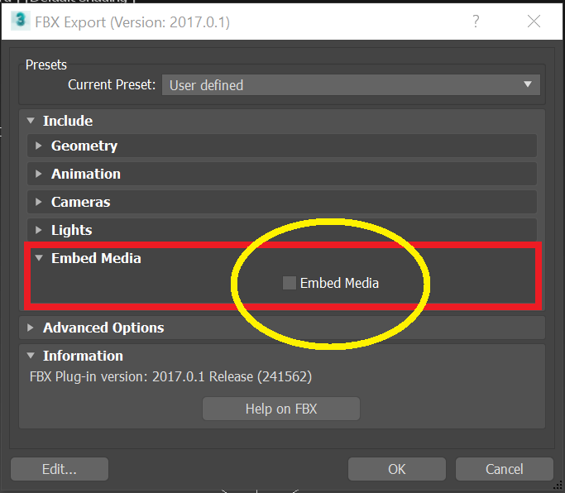

For the export settings that will pop up, under **Include 🡪 Embed Media, **make sure embed Media is checked**, otherwise the materials won’t be exported attached to the object.

Your Object is now ready to be imported into any game engine!

**Recreating Other object features manually**

Since the creation of the initial object set, a number of additional feature dimensions and values have been added, which greatly increase the number of possible objects you can generate.

Although we won’t go into great detail into how to manually generate all these new features manually, I will highlight a few here. As a general rule of thumb, if you want to manually generate any object feature and are unsure then it helps to look over the code & comments, and try to recapitulate what it’s doing.

**Creating “Geodesic” Surface Topology on Quaddles**

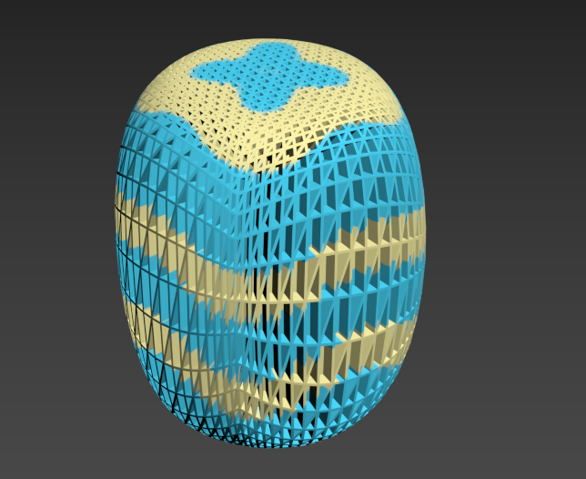

We are going to go over how to create objects that have a regular geometric indentation surface topology like shown above.

These steps are performed after the body of an object has been generated, and a pattern/UVW wrapping has been applied.

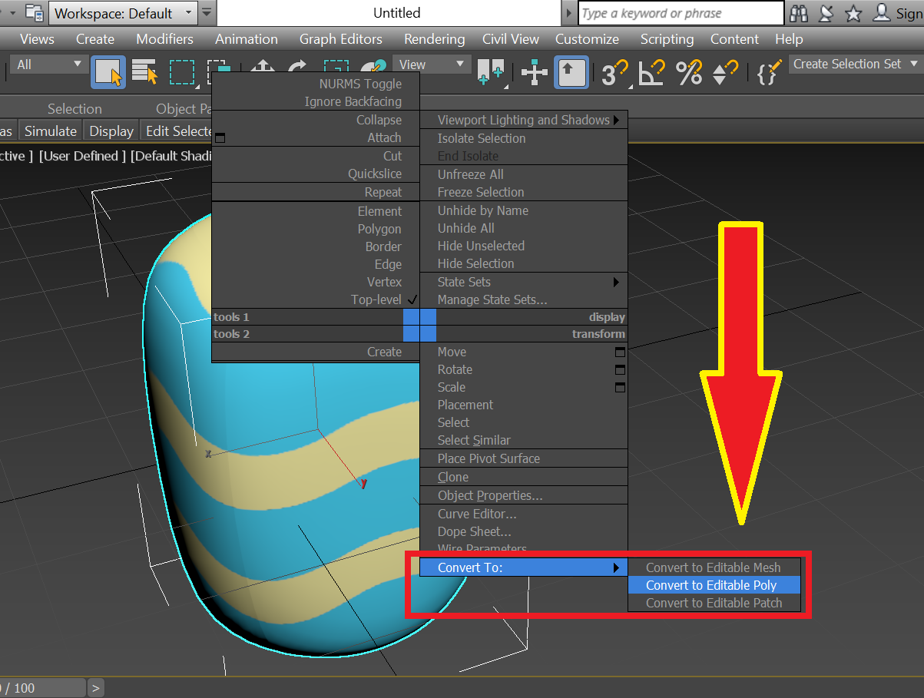

First thing you want to do is **right click** the object, and select **Convert to Editable Poly**

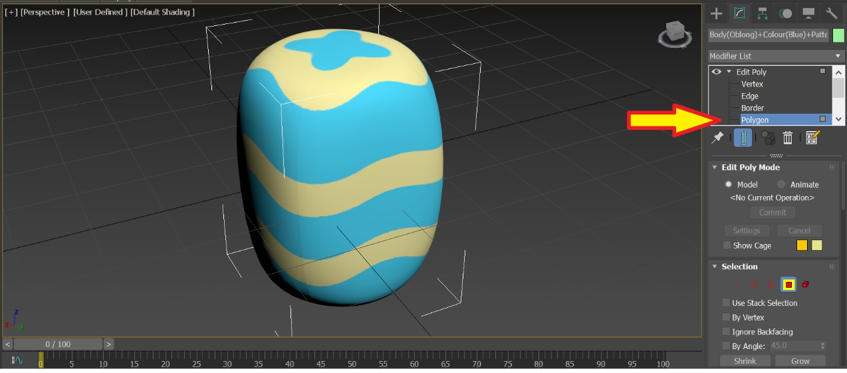

Next you want to add the “**Edit Poly”** modifier to your object. Make sure Polygon is selected in the modifier drop down so that you are able to manipulate the faces of the object.

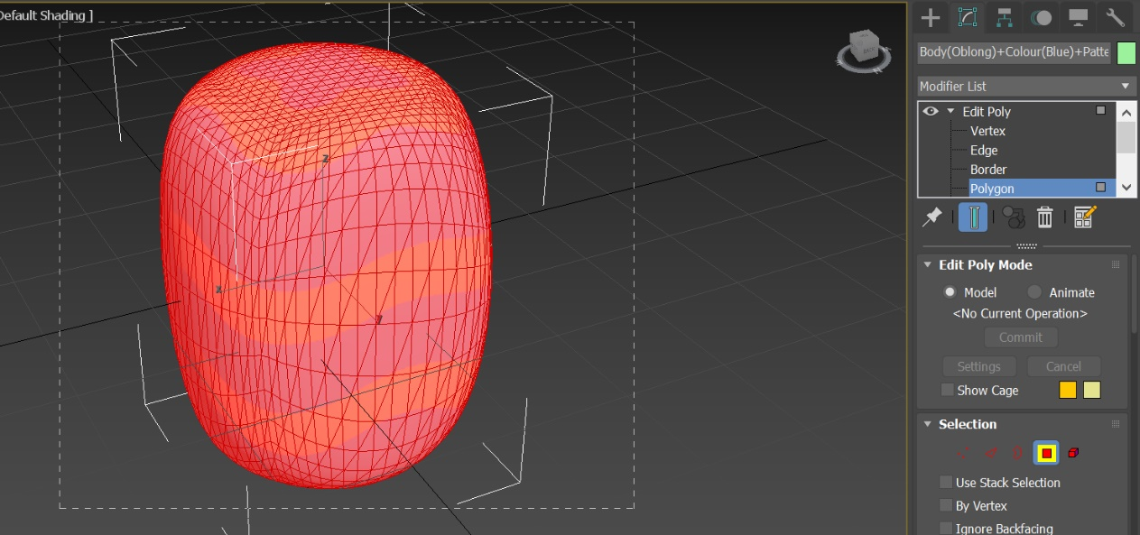

Next you want to select all the faces of the object, the way you do this is by clicking and dragging your mouse curser to select all the faces on the object.

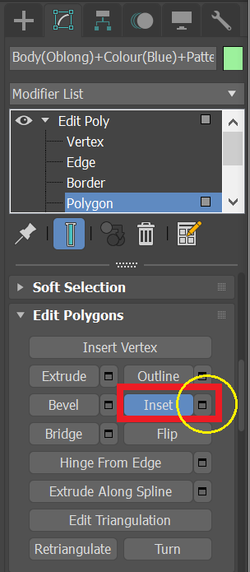

After the faces are selected, you want to select the Inset Settings under the “Edit Polygons” option in the “Edit Poly” modifier

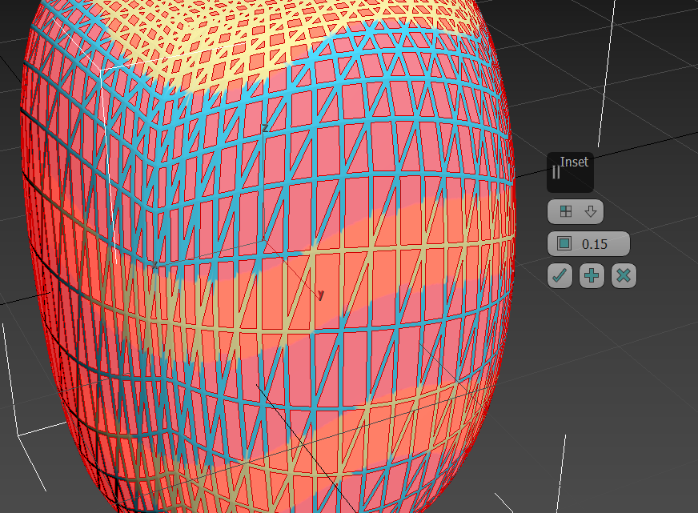

A little “Inset settings” menu will pop up. Set the Inset type to **Polygons** and set the amount to **0.15**. Once you are done, click the checkmark option.

What this essentially does is to SHRINK all the previously selected faces (in effect also creating more faces)

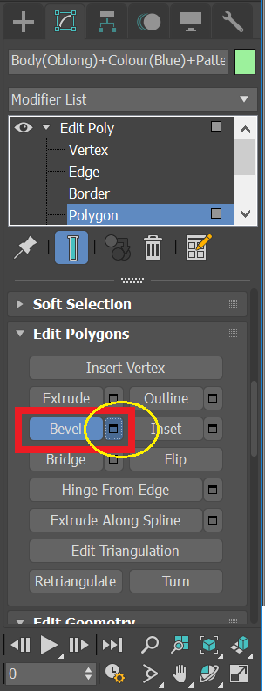

Next you’re going to want to access the **Bevel** options under Edit Polygons, in the modifier options.

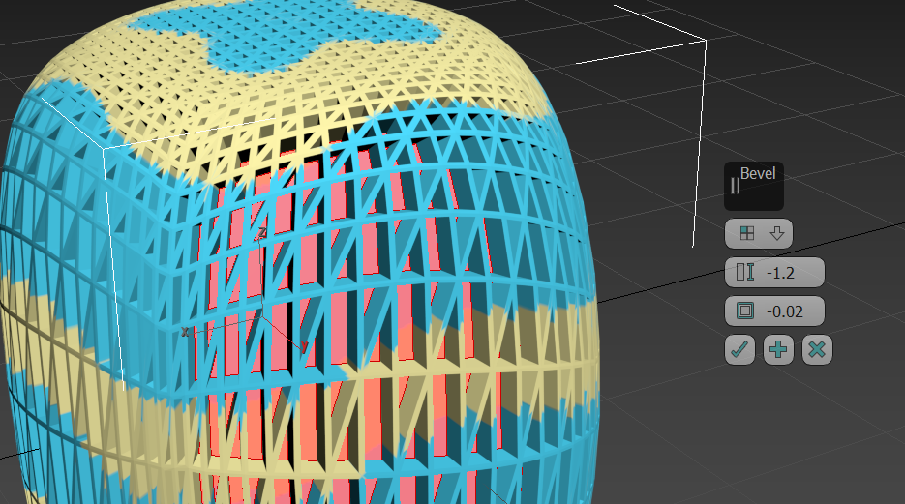

In the Bevel pop-up menu, you’ll want to set the Bevel type to “Polygons”

Next set the Height in this menu to **-1.2**. This will push the selected faces into the centre of the object

Set the “Bevel outline” (3rd option) to **-0.02.** This will set shrink the selected faces just a tiny bit.

Note: These are the values that I have found to work best for our objects, feel free to tweak or slightly adjust these values as you see fit.

Great! Now you have your geodesic object ready to go!

**NOTE:** Creating Geodesic objects for some objects may create strange distortions at certain places, particularly if the object tapers off at some end. The solution to this is to have differential settings for

**Creating Blocky Quaddles**

To create the “blocky quaddles”, you’ll need to first create the “Geodesic” surface as outlined above first.

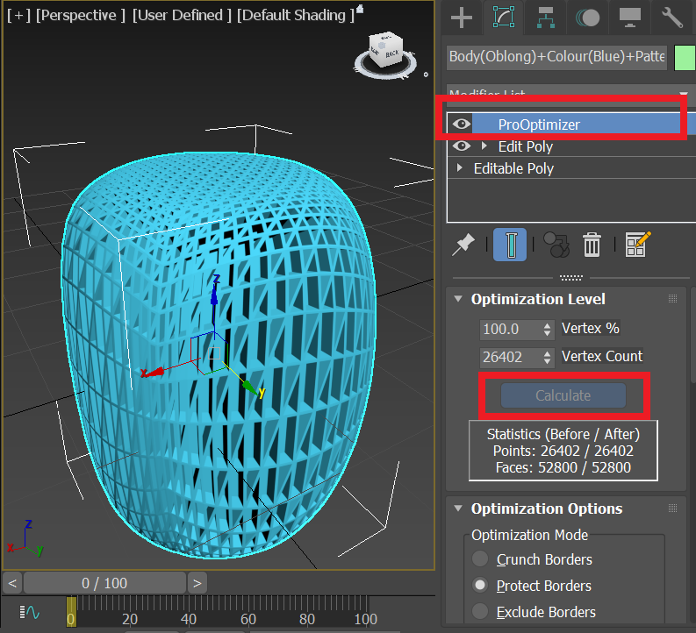

Add the **ProOptimizer** modifier to your object, and click “**Calculate”** under the “Optomization Level” dropdown menu.  
This allows you to now adjust the **Vertex %**

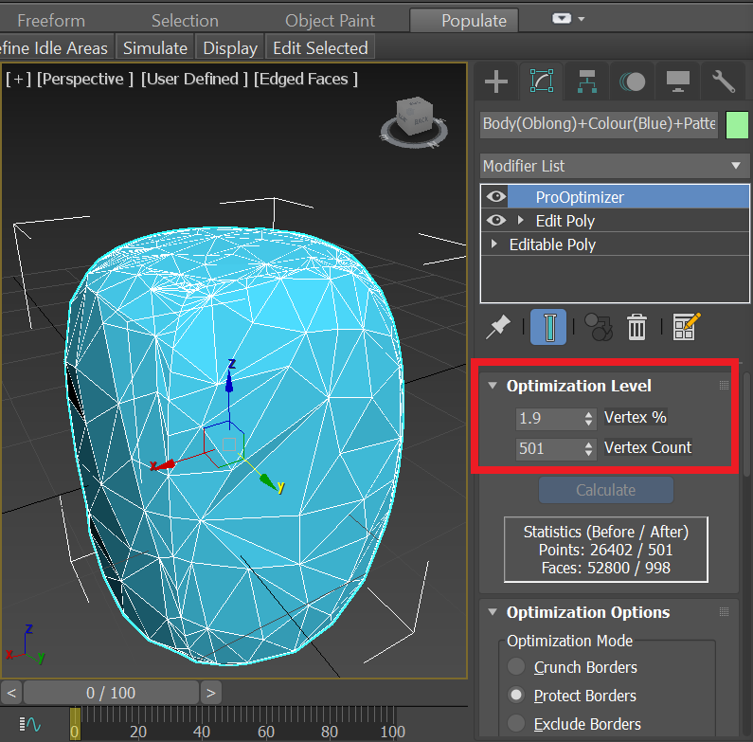

Bring the **Vertex %** down to 1.9% or some other relatively low number (for some objects, you might find that using different values may be optimal). As you can see also, the Vertex Count went from being 26402 to 501.

What this modifier does is to reduce the number of vertices (and in effect polygons) on an object. This modifier is normally used to eliminate unnecessary or redundant polygons on objects in order to speed up processing time. What we’re doing in this case is drastically decreasing the polygon count to the point where it affects the shape of the object giving us this “Blocky” look.

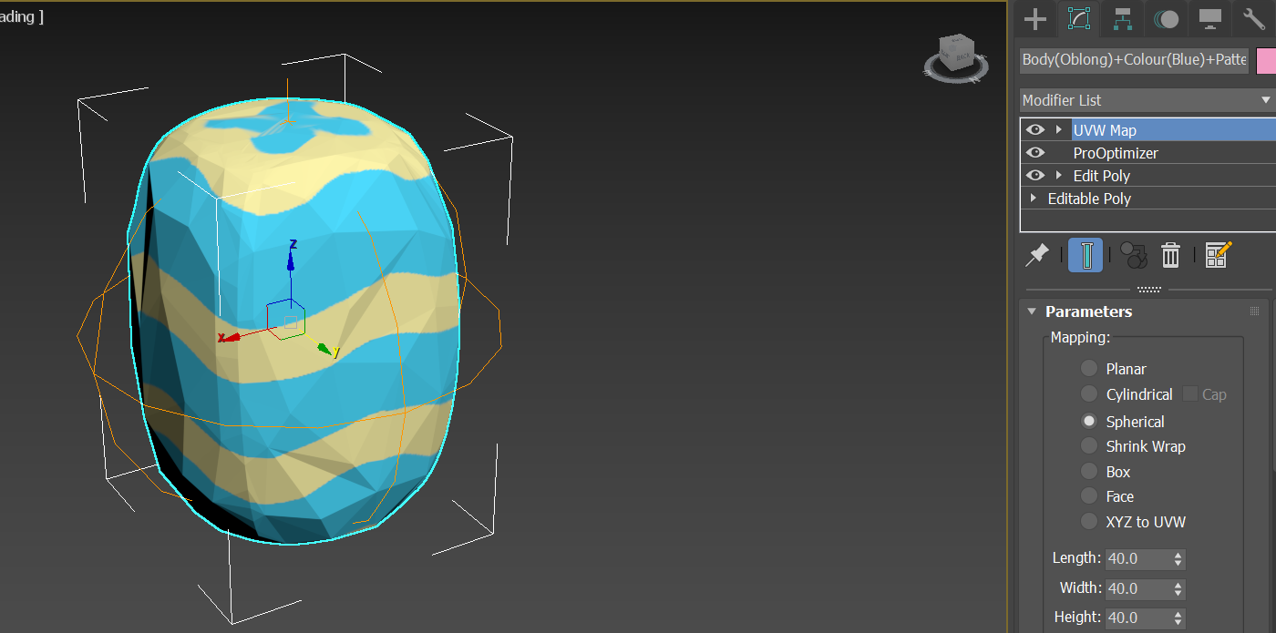

The ProOptimizer modifier tends to mess up the UVW map, so you will probably need to add another UVW map modifier to it to properly see your pattern. (See above on “adding materials to Objects” to see how to do this)

**NOTE:** The Rocky Objects are not completely symmetrical!

**Making Inwardly or Outwardly Protruding Surfaces**

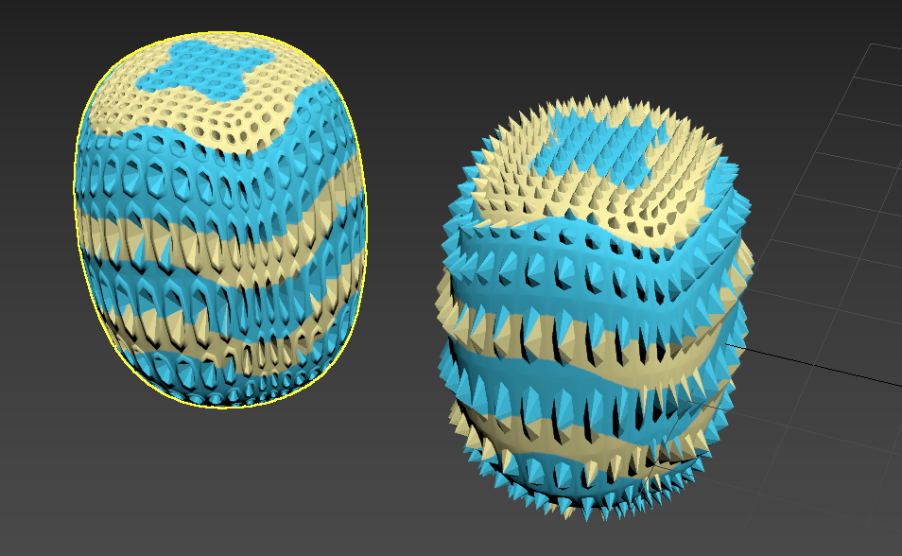

Here, we’ll go over how to make spike objects and objects with holes. Here again, we are starting assuming you’ve already made an object body.

**NOTE:** If you have the *Tesselate* modifier or *TurboSmooth* modifier on an object, then you need to delete these modifiers from the object. These modifiers increase the polygon count normally but will mess up this process if you leave them on.



First you need to convert the object into an editable poly again.



Add the “Edit Poly” modifier and access the inset Settings”

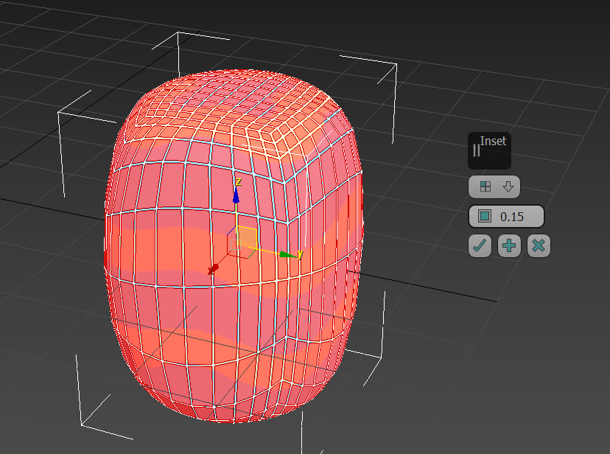

Similar to the geodesic objects, you want to select all the faces on the polygon, set the inset type to Polygon, and set the inset amount to **0.15**

This slightly shrinks the selected faces.



Next open up the **Bevel** settings pop-up menu

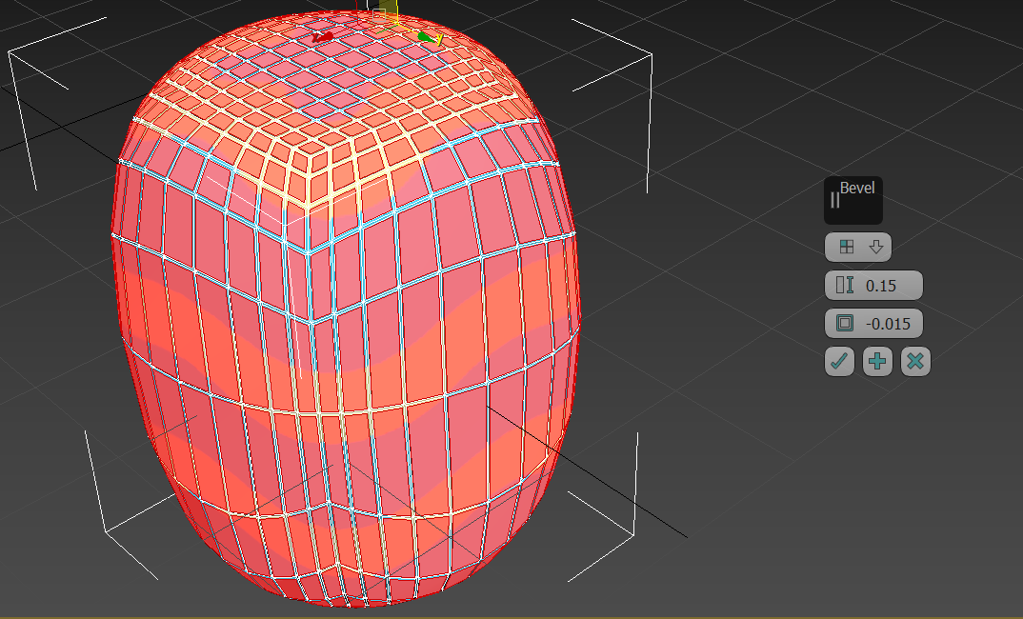

Set the Bevel type to **Polygon** and input the following values

Bevel Height: 0.15  
Bevel Outline: -0.015

This essentially raises previously shrunken polygons, and shrinks them some more

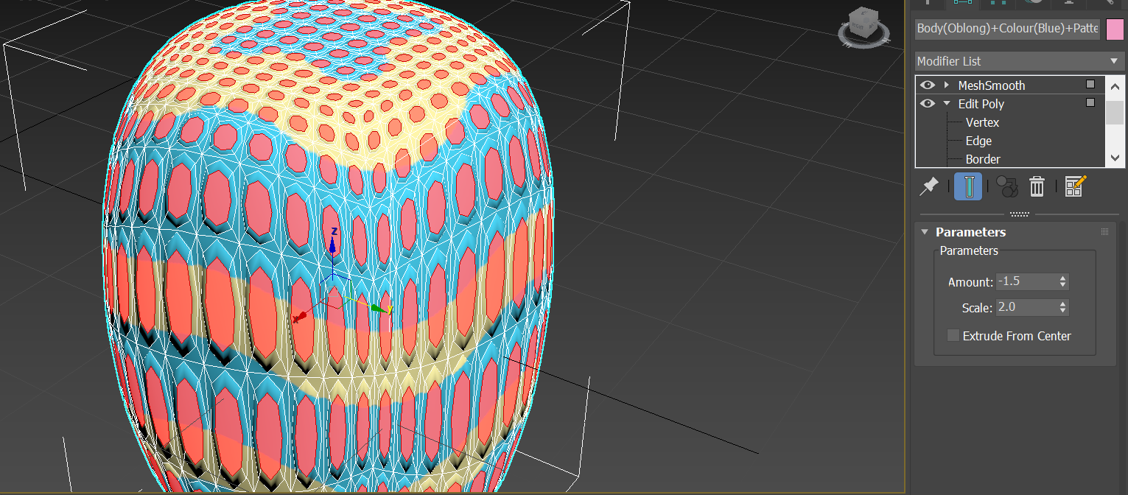

Make sure the same faces are still selected..

Next you’ll want to add the **MeshSmooth** modifier. This will smoothen out the polygons, but also making them more spherical as you can see above.

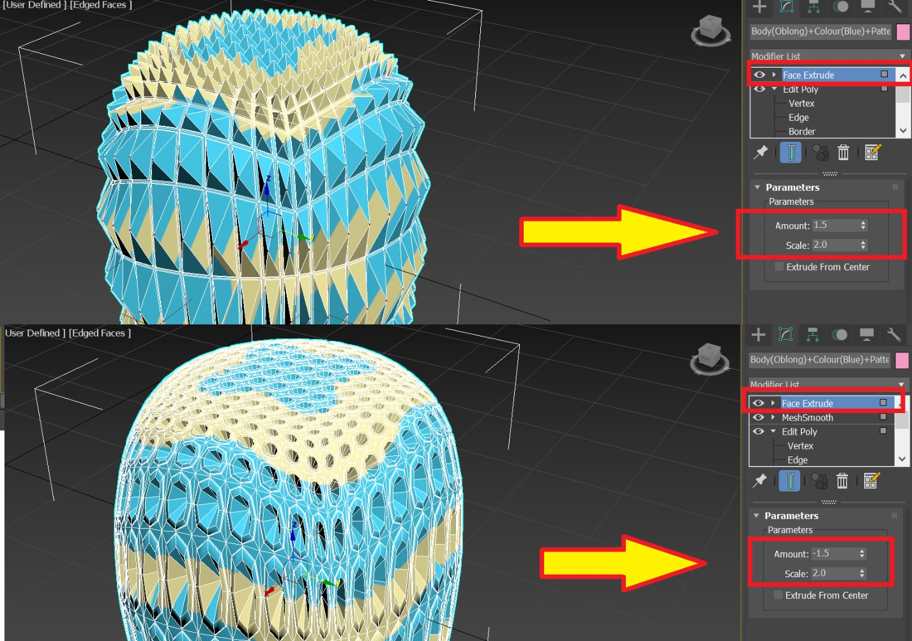

Still make sure the same faces are still selected..

Add the **Face Extrude** modifier to the faces.  
Depending on if you want the surface to protrude inwards or outwards, you can use different amounts.  
**For Outward Protrusions:** Set amount to 1.5  
**For Inward Protrusions:** Set amount to -1.5

Set the **Scale to 2.0**. This essentially shrinks the selected faces so that protrusions/invaginations are pointed.

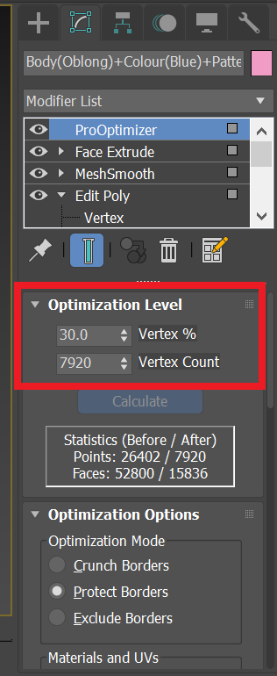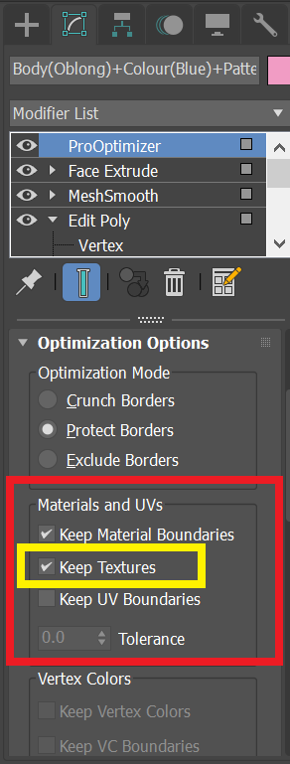

Next you want add the **ProOptimizer** modifier.  
Reduce the **Vertex %** to 30% in the drop down menu to get rid of any unnecessary polygons  
Make sure to have “**Keep Textures”** selected in order to maintain the objects pattern.



This step simply reduces the number of polygons and makes our objects a little more aesthetically pleasing.

**Part 3: Creating Objects Using Existing Scripts**

Here, I will outline how to use the existing scripts without diving too deep into the code.

**1st Check: All Scripts are in the same folder as “Main_Script”**

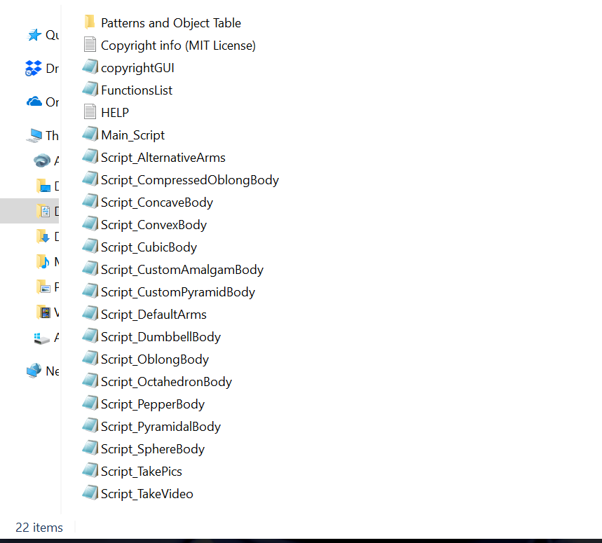

As the name, suggests, ***“Main_Script.ms”***  is the master script which calls upon all other functions to create the objects. The most important other functions are in “***FunctionsList.ms”*** however they are also contained in other scripts (for example “***Script_TakePics.ms***” is called to generate png and jpg pictures of the objects).

In order for ***“Main_Script”*** to properly function, all of the scripts need to be in the same folder as it.

**2nd Check: Textures/Patterns are available**

As you can see in the image above, you should also have png textures available which will be used by the script to generate objects.  
When you generate these textures they should have the following naming convention in order to be recognized by the script;

Pattern(X)+Colour(Y).png or Pattern(X).png or Colour(Y).png  
 For example;  
 Pattern(Checkered)+Colour(More_Orange).png

In your texture folder, you **must** include the png files we provide in order to create our objects.

**3rd Check: Change Folder paths**

When you first download the scripts, you **have to change the folder paths** in the main script for it to work. Luckily there are only three paths you have to change;



**Note**: Include double slashes (“\\”) when indicating folder directories in Maxscript

**Dimensions and values**

One of the two most important variables in the whole script is **“*dims”*** and ***“vals”*** because they dictate the list of dimensions , and feature values that the object(s) will have. By default they are set to the following;

dims = #("Body", "Colour", "Arm_Angle", "Pattern")  
vals = #(#("Pyramidal","Oblong"), #("More_Red","More_Orange"), #("Bent_Up","Bent_Down"), #("Diamond","Checkered"))

Note that the order of feature values (“**vals**”) should correspond to the order of the feature dimensions (“**dims**”) that they’re contained in. (for example, “Body” is the first element of dims, and so are “Pyramidal” and “Oblong” in vals).

By default, the script will generate all possible combinations of features, unless an objTable is provided.

The following is a full list of all the possible values of **“dims”** and **“vals”** which can be used to make objects;

|  |  |  |  |  |
| --- | --- | --- | --- | --- |
| **Body** | **Colour** | **Pattern** | **Arm_Angle** | **Arm_Ends** |
| Pyramidal | More_Red | Diamond | Bent_Up | Pointed |
| Oblong | More_Orange | Checkered | Bent_Down | Blunt |
| Compressed_Oblong |  |  | Straight | Flat |
| Octahedron |  |  |  | Flared |
| Cubic |  |  |  | Spherical |
| Spherical |  |  |  |  |
| Concave |  |  |  |  |
| Convex |  |  |  |  |
| Dumbbell |  |  |  |  |
| Pepper |  |  |  |  |

|  |  |  |  |  |
| --- | --- | --- | --- | --- |
| **Smoothness** | **Transparency** | **Hat** | **ArmCount** | **Pattern_Inversion** |
| Smooth | Opaque | Pyramidal | 0 | Inverted |
| Wrinkled | Transparent | Oblong | 1 | Normal |
| Inward_Protrusions |  | Compressed_Oblong | 2 |  |
| Outward_Protrusions |  | Octahedron | 3 |  |
| Blocky |  | Cubic | 4 |  |
| Hairy |  | Spherical |  |  |
|  |  | Concave |  |  |
|  |  | Convex |  |  |
|  |  | Dumbbell |  |  |
|  |  | Pepper |  |  |

**Done!**After making these 3 checks, you should be ready to just run “Main_Script.ms” by selecting it and hitting ***ctrl+e.***

You will be greeted with a short copyright intro, after running the script.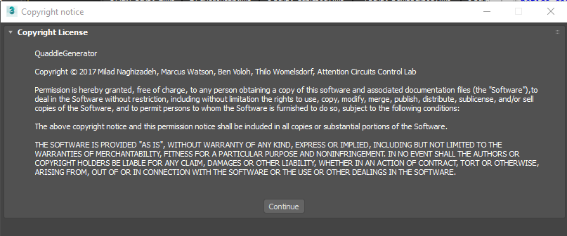

You will need to click continue to generate the object set. Essentially, the important part here is that you are free to “use, copy, modify, merge, publish, distribute, sublicense…” etc. as long as you provide the copyright notice that we provide and give us credit.

The next section will go into a little more depth about how “***Main_Script.ms”*** works.

**Part 4: Main Script Outline**

**Copyright intro:**

The main script to be run is **“Main_Script”** which makes use of functions in separate scripts. If you select “Main_Script” and hit *ctrl+e* you will run the script and greeted with a short copyright intro

fileIn "FunctionsList.ms"

Above the part of the script which generates the copyright pop-up window is a line that inserts the code of another script called “FunctionsList.ms”. This script will be covered later, however briefly, it contains all the main functions needed to generate the objects. In the way that maxscript works, functions need to be defined beforehand at the top of the script before they can be called.



Above you can see how the copyright pop-up screen is coded. With “try (closeRolloutFloater rof) catch()” we see if there are any other windows open with the name “rof” and close them if they are. A “rollout” is the window that pops up.

button 'continueButton' "Continue"

^This is defining the button at the bottom of the Window, and attaching the text “Continue” to it. It’s given a label of “continueButton”

on continueButton pressed do

The main body of the main script is executed after the continue button is pressed.

closeRolloutFloater

After the object generation is completed, this will close the window.

**TIP:** An easy way to create and edit rollout windows is using the maxscript “rollout editor” GUI. To access it, in MAXscript click **Tools 🡪 Edit Rollout.** You will get a window like the one below.

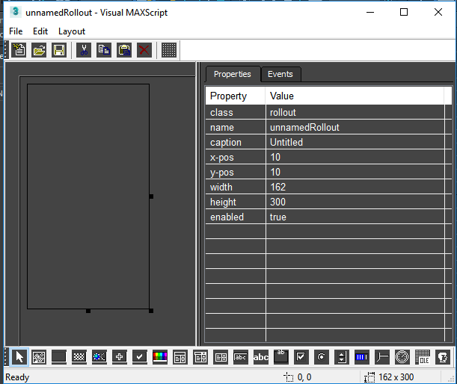

**Outline of Main Script:**

Inside the copyright rollout window brackets you will see the following code…

sysInfo.currentdir = "C:\\Users\\Milad\\Documents\\3dsMax\\important Scripts 2.0\\Quaddle_Generation_27\\"

Whatever you set the current directory to, **all the scripts need to be located in that folder.** In this case, the current directory is set to “Quaddle_Generation_27” folder

**Defining the folder paths**

--FOLDER PATHS--  
objTable = openFile "C:\\Users\\Milad\\Desktop\\objects test\\hi\\object_table.txt"  
savePath = "C:\\Users\\Milad\\Desktop\\newObjs\\TESTING\\"  
makeDir savePath  
--textures for main body  
textureMainPath = "C:\\Users\\Milad\\Documents\\3dsMax\\important Scripts 2.0\\Quaddle_Generation_27\\Patterns and Object Table\\Patterns and Colours\\"

In the next part of the script, you have to define the folder paths for the object Table (objTable), and where your objects will be saved (savePath). “textureMainPath” is the path to the textures you want to apply to your objects.

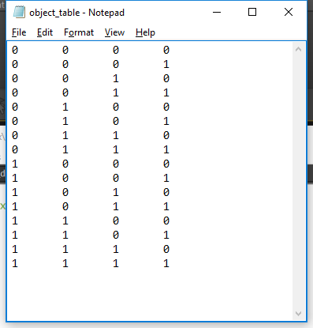

Above is an example of the object table. This is a text file where each row represents one object, and each column represents a feature dimension. For example, if you are using the pyrimadal and oblong feature dimensions, the first column might represent a body dimension where 0 denotes a “pyramidal” shape and 1 denotes a “rectangular”(or oblong) shape.

**Note** that an object table is not necessary, and if the script can not find it, than it will generate all possible combinations of features on an object. If the script can not find an objTable or is not defined, than the variable of objTable will be set as “undefined”.

**Defining Feature values and Dimensions**

dims = #("Body", "Colour", "Arms", "Pattern")

vals = #(#("Pyramidal","Oblong"), #("More_Red","More_Orange"), #("Bent_Up","Bent_Down"), #("Diamond","Checkered"))

Two arrays called “dims” and “vals”, are the feature dimensions and feature values of the objects we want to create respectively.

Two other possible feature dimensions that are available to use are “Smoothness” and “Transparency” as well as other feature values within these dimensions(See below).

dims = #("Body", "Colour", "Arms", "Pattern",”Smoothness”,”Transparency”)

vals = #(#("Pyramidal","Oblong","Concave","Spherical","Octahedron","Cubic"), #("More_Red","More_Orange"), #("Bent_Up","Bent_Down","Straight","Blunt","Pointed","Coned"), #("Squiggly","Polka"),#("Wrinkled","Smooth"),#("Opaque","Transparent"))

objNames = #()

objNames is an empty array which we will store the names of all the objects we create in our object set.

pyramidpercentage = 0.5  
oblongpercentage = 0.2  
concavepercentage = 0  
octahedronpercentage = 0  
cubepercentage = 0  
spherepercentage= 0.3

**If** you set “Custom” as one of your object body features, than you have the option of creating objects that exist as intermediate values between body morphs. In the above code, we specificy that this custom object will have 50% pyramidal, 20% oblong, and 30% spherical character. Note that the values need to add up to 1! (0.5+0.2+0.3 = 1)

**Is the object Table present or not?**

if (objTable == undefined) then (readTheTable = false)  
else (readTheTable = true)

If the script is unable to find the objTable, than it won’t try to extract the object details from it. Let’s examine the code that will generate the object table



With “seek objTable 0” we go to the first line of the object table…  
Let’s go through this code step by step…

While not(eof objTable) do (

objDetails = readLine objTable  
…  
)

Each time we go through the while loop, the readLine function stores a line of the objTable into objDetails, and then automatically goes to the next line of objTable.

As long we don’t end up at the last line of the object table (eof objTable), then we keep going through the while loop.



Based on the values of objDetails(e.g 0 1 1 0 ), objvals is set to be a particular combination of features.

Note that within objDetails, tabs separate the values, such that we have 2x the number of dimensions + 1 in objDetails.count. In order to reach the maximum number of dimensions in the for-loop and not more we set the end point of the for-loop as (objDetails.count + 1)/2)

Considering the tabs, we want to access the 1st, 3rd, 5th, 7th etc values in objDetails instead of the 1st, 2nd,3rd & 4th. To get the proper index in objDetails, we do 2xdimCount – 1

objvals[dimCount] = vals[dimCount][objDetails[((2*dimCount)-1)] as integer + 1]

Since objDetails actually contains string arguments, we need to convert it to an integer using “as integer”.

We add one (+1), because Maxscript is not a zero-indexed language, and need to access the correct element in the vals array for a particular dimension.

MakeObject()

MakeObject() function is called to create an object based on the values specificied in objvals.

*As an example…*

Suppose that we previously had set the feature values as follows

*vals* *= #(#("Pyramidal","Oblong"), #("More_Red","More_Orange"), #("Bent_Up","Bent_Down"), #("Diamond","Checkered"))*

If the values of objDetails was (0 1 0 1), and we were on dimCount = 2, then

*objvals[2] = vals[2][objDetails[3]+1]*

objDetails[3] = 1 so therfore…

*objvals[2] = vals[2][1+1]*

So therefore…

*objvals[2] = vals[2][2]*

If we look at the previous array values for “vals”, then we notice that the second value, within the second array is "More_Orange". Therefore…

objvals[2] = "More_Orange"

The second dimension of the object will be "More_Orange". The for-loop will continue untill all feature dimensions are filled.

For the objectDetails of (0 1 0 1), and vals of #(#("Pyramidal","Oblong"), #("More_Red","More_Orange"), #("Bent_Up","Bent_Down"), #("Diamond","Checkered")), then we will have the following values for objvals;

objvals = #(“ Pyramidal”,” More_Orange”,” Bent_Up”,” Checkered”)

This will be fed into the MakeObject() function to create an object with these features. After this, the code will move to the next line in objTable to fill objDetails, and make the next object.

**If there is no object table present.**

If there is no object table present than the following code will be run…



The global variables objVals, allObjects, and i are all used the “DefineAllObjects()” function to generate all possible combinations of features on an object.  
DefineAllObjects() is a recursive function, requires as input 1 in order to get started, and is found in “FunctionsList.ms”. After all objects are defined, we sequentially go through them in a for loop, store them in objVals, and then use MakeObject() to create the object based on objVals.

**Part 5: Functions List**

We will next cover the functions in “FunctionsList.ms”….

**DefineAllObjects() (First Function in script)**

The first function defined at the top of the script is DefineAllObjects(), which is called whenever we don’t provide an object table to explicitly define the objects we want to create.



It creates an array containing the feature values of all objects possible. It’s only input dimCount, must be initially set to 1 in order to work. Let’s go through it more in depth…

for valCount = 1 to vals[dimCount].count do(  
 objVals[dimCount] = vals[dimCount][valCount]

Starting from the first feature dimension (dimCount=1), we go count through all the feature values in that feature dimension.

if dimCount != vals.count then(  
 DefineAllObjects(dimCount+1)  
)

If we are **not** on the last feature dimension count, then we call the function itself again, and go to the next feature dimension (dimCount+1). The previous lines of code will be repeated until we get to the last feature dimension.

else if dimCount == vals.Count then(

i = i +1  
temp = copy objVals #nomap  
allObjects[i] = temp

)

On the last feature dimension, we store all values of objVals into the allObjects array, which is the ultimate output of this function when it’s finished. “Main_Script” takes this array, cycles through it and creates the objects based on it.

**MakeObject() (Bottom of the Script)**

Below the **DefineAllObjects()** function, you will find many other functions that take pictures, and videos of the objects, as well as create the main body, the arms, apply the pattern etc. As previously mentioned, functions which are called last or contained within other functions should be at the top of the script because they need to be defined before they can be called.

For the sake of simplicity we will jump to the “MakeObject()” function which is the last function in the script, and typically will be the first function to be called.



Americans who spell colour as “color” will be pleased to know that the script corrects this since the rest of the script scans for the string “Colour”.



Similarly, in the past the only arm related feature dimension available was called “Arms” which consisted of the arm angle. If anybody is used to this older system, and just inputs “Arms” as a feature dimension then this is translated into “Arm_Angle”. “Arm_Ends” and “ArmCount” have since been added as additional feature dimensions as well…



Here, we make an objName string for the object we are about to make. The name is based on the particular features (objVals) and dimensions (dims) of the object. As an example, an object may be called; “Body(Oblong)+Colour(More_Red)+Arms(Bent_Up)+Pattern(Checkered)”

qArray = #()

qArray is an empty array which will be filled with all the quaddle components (e.g. body and arms).



“findItem” looks to see if any particular feature dimension is specified, and if so calls the function to make that dimension. Some of these functions take qArray as input, and fill it in with more values. Above is a more barebones version of the script that you might have found in earlier versions. Newer scripts might include slight variations on this but the basic idea is the same; see below as an example.

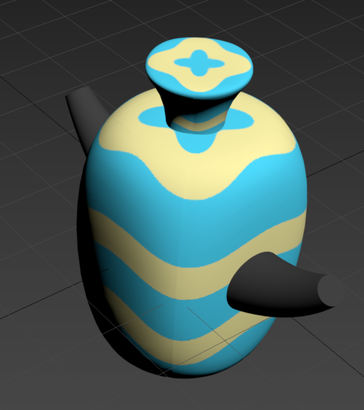

In the scripts there is the option of specifying a “Hat” dimension to the *dims* variable, and where you can set the corresponding *objvals*to any object body feature value (As an example you can have an oblong object, with a concave hat as you can see in the image above)



The same functions that makes the main body and apply the pattern is used to make the hats and apply the pattern to the hats. (*MakeBody() and ApplyTexture())*

  
*scale* shrinks the object to 45% of its original size

SmoothenEdges(hatBody)

SmoothenEdges is a function that adds more polygons to the objects.

***After Making potential hats and main object body***



If there is a hat made, it is positioned at the top of object. objbody.max[3] is the maximum y-position of the main object body. Since the pivot point of the hat is set to the centre of the hat, setting it’s y-pos to this point will embed exactly half of it onto the top.

*Deleting Imbedded Parts of the arms in the objects*

I have added the functionality to delete imbedded parts of the arms within the main body of the obect.

  
If arms are present, then we cycle through each of the arms and subtract objbody from listOfArms[armCount].

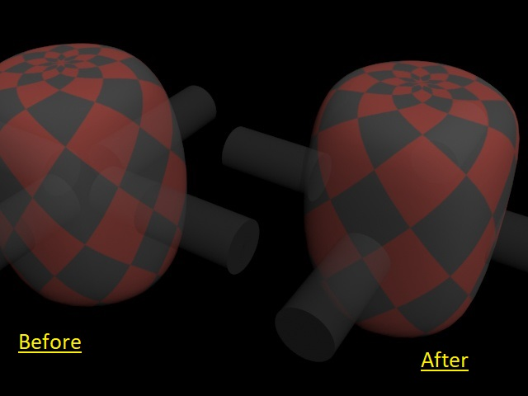

Above you can visualize this with two transparent objects, with the one on the left as normal and the one on the right having imbedded parts of the objects deleted.

As you can see, this functionality would be useful especially for 3D transparent objects where you may not want the participant to see the interior parts of the object.

**NOTE:** Currently this part of the script has been **commented out** because it produces **glitchy results and aberrations** with some objects. Currently this feature does not seem to work properly for the follow objects;

* Dumbbell objects
* Pepper Objects
* Wrinkled objects

***Saving the Object***

group (qArray as array) name:objName

All elements in qArray are grouped together, and assigned the name we previously stored as a string.

Takepics 20 120

The Takepics function takes two pictures of the object from a specified elevation, and distance. In this example, 20 degrees elevation and 120 distance is where the picture will be taken from.

Takevideo 20 120

The Takevideo function works in the exact same way except it takes videos of the objects rotating 360 degrees.

**NOTE:** In the version of the script provided, the Takevideo function is likely **commented out**. This is due to the fact that the video function can at times take up substantial computational resources, and **will significantly slow down** your quaddle generation. This is particularly true for some of the more complicated objects or those with more polygons such as the hairy**,** geodesic, and pointy surface topology distortions.



“select qArray” has the object selected for the exportFile to work.

FileDir and fileName delineate the directory of where the fbx is to be saved along with the file itself.

FBXExporterSetParam "EmbedTextures" true  
exportFile fileName #noPrompt selectedOnly:true using:FBXEXP  
delete qArray

Note that “EmbedTextures” is set to true, in order for the textures to export with the fbx file. This is equivalent to the “Embed Media” option, if we manually export the fbx files (see below).

#noPrompt means that there is no pop-up window when we export.



Finally “delete qArray” deletes the object in our scene so we can move to the next object, and so that it won’t be in the way when we take pictures or videos using some of the aforementioned functions.

**MakeBody()**

This function is called to make the main body of the object.

fn MakeBody body:objVals[findItem dims "Body"] …

The index of dims which contains the word “Body” is the index of objVals which contains the feature value of the body dimension. The variable body is set to this body feature value (e.g. “Oblong” or “Pyramidal” for example)



Depending on the body feature value, more specific functions such as MakeOblongBody() are called. Only two are shown here for simplicity, however one exists for each body shape.

fn MakeOblongBody pattern = (include "Script_OblongBody.ms")

When these body functions are called, they make reference to separate scripts. With “include” its as if we’re essentially copy and pasting the code in.

append qArray objbody

objbody is added to the initially empty qArray

bodyOutput = #(objbody,polygonner,qArray)  
return bodyOutput

The end result output of MakeBody().

**ApplyTexture()**

This function applies the texture and proper UVW mapping to the object body



We have created a special notation to denote patterns in which the colours generated have been inverted. Compare the following two patterns;

 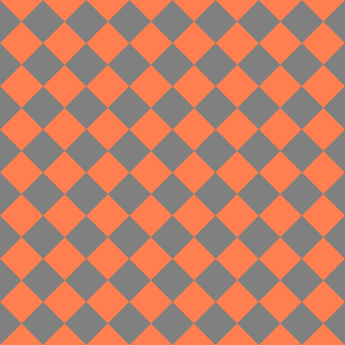 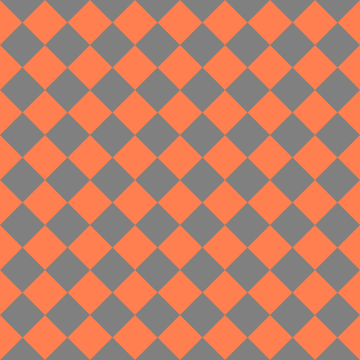

The difference can be very difficult to spot, but if you look closely the pattern on the right differs from the left in having the colours flipped. If you include an “*Inverted”* feature value and “*Pattern_Inversion”* feature dimension, than the script will look for png files which will end in “_inv”.

Therefore if you want to use this feature dimension, than you will need png files which ware named something like this.

Pattern(Diamond)+Colour(More_Orange)_inv.png



The script checks to see if there is a pattern or colour feature dimension specified by dims.

texturePath is location of the png texture that we want to use. Depending on the pattern and colour of the object being created, different png’s will be retrieved.

**NOTE:** Your pngs must have the following naming system; “Pattern(Name of Pattern)+Colour(Name of Colour).png”



If you have only “Pattern” or only a “Colour” feature dimension, than the script will still look for your texture.

if (findItem dims "Body" != 0) then (body = objVals[findItem dims "Body"])

body variable is set.

map = uvwmap()

The “UVW map” modifier needs to be added to every object for a texture or pattern to properly apply to that object. Here we are calling it “map”

**Map Specifications**

map.maptype = 1

We have to set the “map type” of the UVW map meaning the kind of wrapping technique used to apply the textures to the objects. In this example, a map type of 1 means that a cylindrical mapping technique is used. For a map type of 2, a spherical mapping technique is used

**NOTE:** The most up to date version of the script uses cylindrical mapping (map.maptype = 1) for all objects except the oblong which uses spherical mapping (map.maptype = 2).

map.length = 80  
map.width = 80   
map.height = 120

We might also want to change the dimensions of the wrapping in order to achieve something that looks more aesthetically pleasing.

map.utile = 2.5  
map.vtile = 2.5

Similarly, we can change how many times a map is projected over the surface of an object. “U” and “V” are analogous to X & Y respectively.

A higher tiling number will cause smaller and more fine grained textures. There is an option to adjust the v-tiling as well however for most textures this won’t affect anything since it corresponds to the 3rd dimension, and most textures would normally be 2D.



Above we see an example of how we might apply different wrapping techniques depending on the texture, or object that it’s being applied to. In the above example, a Concave Polka object would have a different wrapping method than then a Concave Squiggly object, and both would have different wrapping from a completely different object shape.

The version of the script you may be using may have different specifications for these parameters with different conditionals for different objects, however the key point here is that the following parameters are tweaked/adjusted to make sure that 2D png images are optimally applied to each object;

**map.maptype  
map.utile  
map.vtile  
map.height  
map.width  
map.length  
map.cap**

Now on to actually apply the texture…

outMap = Bitmaptexture fileName: (texturePath)  
objbody.material = standardMaterial diffuseMap:(outMap) showInViewport:true;

We need to add the texture we want to to a “diffuseMap” which is a Bitmaptexture in our case. We then make the objects material as that diffuse map. Since a proper UVW modifier was previously added, and showInViewport is set to true, than at this point the objects should have a visible texture.

textureOutput = #(textureMainPath,map,objbody,outMap)  
return textureOutput

The object, now with a texture applied is output by the function along with any folder paths it used or textures it applied.

**MakeArms()**

fn MakeArms dims:dims objVals:objVals objName:objName objbody:objbody

Like other functions, the MakeArms() function will grab the variables it needs to do its proper job



Various variables take their respective values from objVals. If a dimension for that variable does not exist, then a default value is presumed (ie “Flat” for arm end and straight for arm angle)



Similarly the number of arms on the object is specified by "ArmCount". If it's not present then the number of arms is set to 4.

if (arms == "Spherical") or (armEnds == "Spherical") then (listOfArms = MakeSphericalArms(objName)(numberOfArms)(objbody)(body))  
else (…

In the script you also have the option of setting objects to have spherical arms. This calls a custom script called “**Script_SphericalArms.ms**” instead of the “**Script_AlternativeArms.ms**” that’s used to make all the other conical/cyndrical arms.



In the picture above, we can see what the spherical arms look like…

**NOTE:** Putting “*Spherical”* as any one of the objVals, that correspond to any of Arm related feature dimensions (i.e. “Arm_Ends” or “Arm_Angle” in “dims”) will negate any other features such as bluntness or angle.

  
If arms are specified as bent downward then they are given +45 degree angle and if they are specified as downward then they are given -45 degree angle. Otherwise angle is set to 0 as default



Most arms are made as cones, which have their radius’s specified by two different values. Thus if we wanted “Pointed” arms like below then we would need a large initial radius narrowing into a radius of essentially 0 (a point) (see object below as an example). If the arm ends are not specified then the arms are set to be standard cylinders by default.

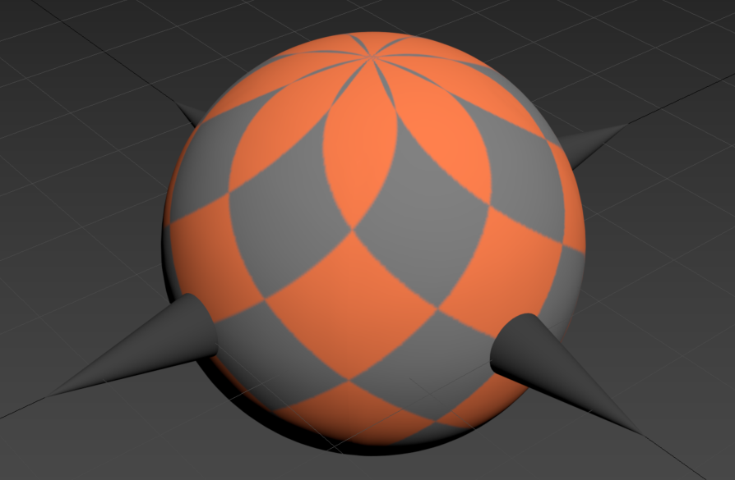



MakAlternativeArms() is the function that contains the script “**Script_AlternativeArms.ms**” to make the arms. This script is described in detail further below.

In your scripts folder, you may also find a script called “**Script_DefaultArms.ms**”. Despite the name, none of the arms are made using this script anymore however is included in case anyone wants to use them.

**ManipulateSurfaceTexture()**

*Wrinkled Objects*



If you want a wrinkly object, then this function will add the “displace” modifier to the surface, which can contort and deform the shape. Here I give it reference to an png file called “noise2d” in order for it to generate random contortions throughout the entire surface.

Similar to the UVW mapping techniques, how this displace function is applied to the object can be tweaked by various paramaters such as maptype, and map length etc.

Note: If you want to generate wrinkled objects than you need to make sure that you have the noise2d.png file in your textures folder.



If you want more information about how some of these other surface topologies are generated, please refer to the end of **Part 1** in the manual to see how they are generated. In the script, you are essentially inputting the values that you saw earlier in the manual.

**ManipulateTransparency()**

for qArrayCount = 1 to qArray.count do(

if qArray[qArrayCount] != undefined then(

if (transparency== "Transparent") then(

qArray[qArrayCount].material.opacity = 25

)

)

)  
return qArray

This typically tends to be the last function to be called and will manipulate the transparency of all parts of an object that can be made less opaque. Note that opacity is set to 25 which means the object is 75% transparent, and 25% opaque.

**Part 6: Other Scripts**

**Script_OblongBody**

This is the script that generates the main body of the Oblong quaddle.

local controlPoint = ffd_3x3x3()

“controlPoint” is assigned as 3x3x3 “free form deformation points” which can later be applied to any object. By adding these ffd control points to objects, we can morph their shapes by moving them around.

local objbody = Box()  
objbody.length = 20  
objbody.width = 20  
objbody.height = 40

objbody.lengthsegs = 10  
objbody.widthsegs = 10  
objbody.heightsegs = 10

A 20x20x40 (arbitrary 3Ds Max units) rectangle is created and is given the name “objbody”. The length, width and height of the object are all divided into 10 segments (more, or less segments can affect how the object body is deformed later on).

addmodifier objbody (spherify())  
addmodifier objbody controlPoint  
animateAll controlPoint

The spherify and ffd_3x3x3 modifiers are added to object. “animateAll” allows the objects control point to be modified.

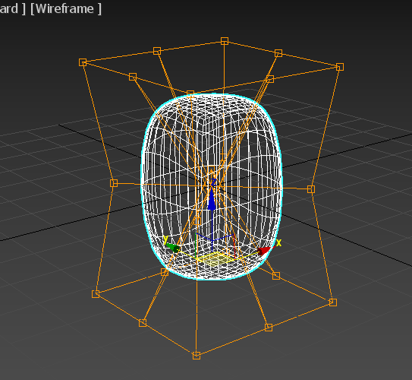

In order to create the oblong body, there is a number of transformations to be done;

1. We need to stretch along the z-axis by moving the perimeter points of the top layer up and the perimeter points of the bottom layer down
2. The midpoints of the middle layer need to be pushed in towards the centre to “squish” and create more flat faces.
3. Similarly the centre points of the top and bottom layers need to be pushed in towards the centre to make the top and bottom faces more flat
4. The corners of the middle layer are brought in closer to the centre in order to lessen the bulge of the middle.

This is accomplished in the script below.



When we see something like this;

controlPoint.control_point_2[1]

This is referring to the 2nd control point in our control point matrix. The [1] indicates that we are accessing the x-axis value of this coordinate. [2] similarly would refer to the y-axis and [3] to the z-axis.

oy11 = controlPoint.control_point_11[2] + midPointIndent

In this case for example, we’re adding “midPointIndent” (which has the value of 0.5) to the default y-axis value of the 11th control point and assigning it to the 11th coordinate.

controlPoint.control_point_1 = [ox1,oy1,oz1]  
controlPoint.control_point_10 = [ox10,oy10,oz10]  
controlPoint.control_point_19 = [ox19,oy19,oz19]  
controlPoint.control_point_4 = [ox4,oy4,oz4]  
…

The shifted control point values are then assigned to the actual control points.

**Side note on Free form deformation coordinate system.**

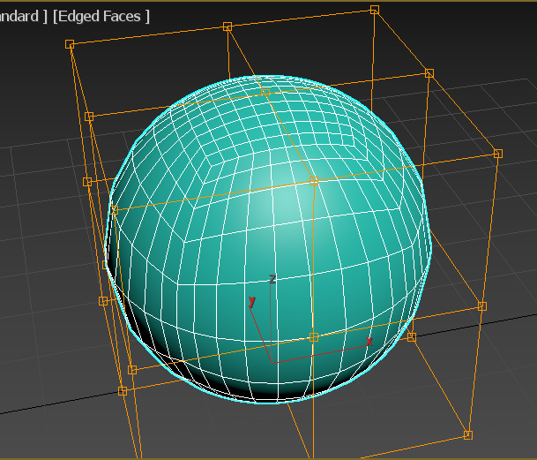

The deformation points that are manipulated in the script are numbered 1-27; and each have defined position in 3D space.

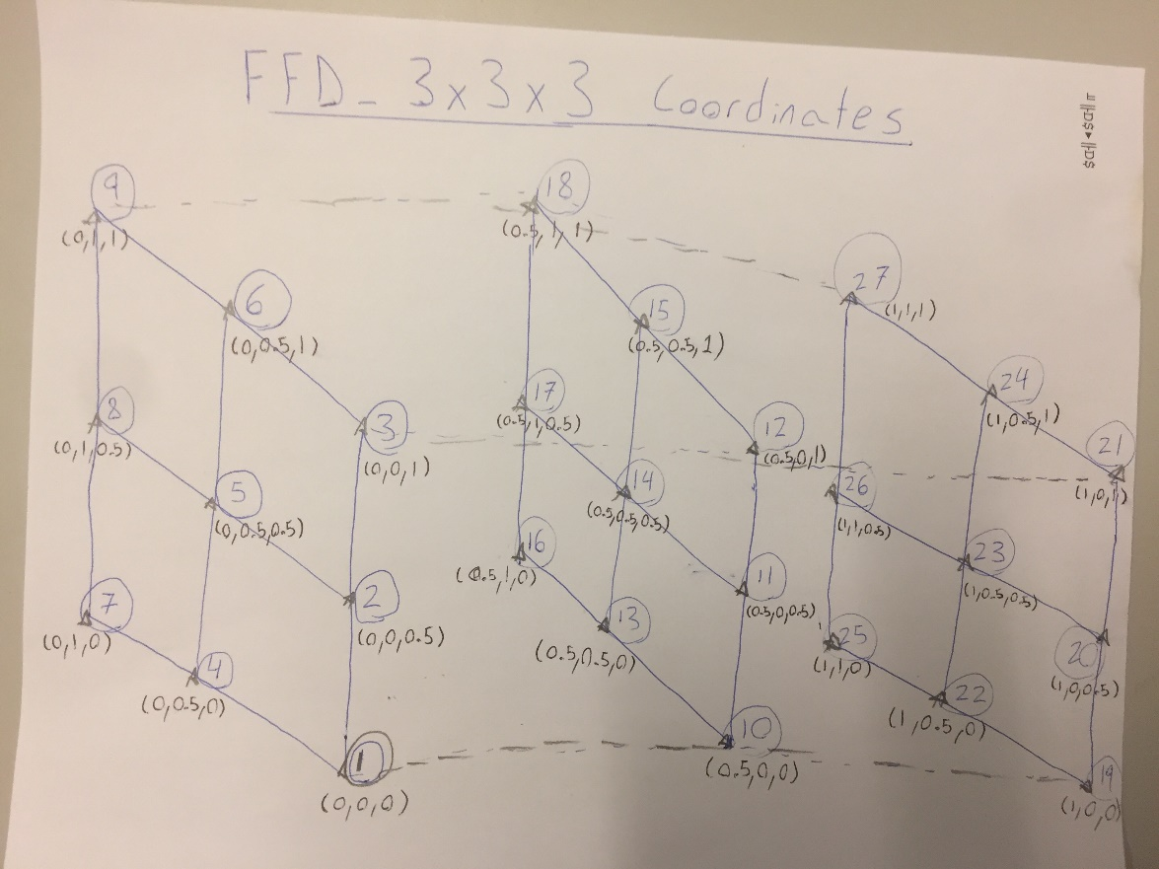

The coordinate system for the “FFD_3x3x3” modifier is as shown above. Control point numbers are shown in circles and coordinates are shown in brackets.

It’s important to note that the above coordinate system only applies to the ffd_3x3x3 modifier. When using other modifiers, (like the “ffd_box” modifier for example which pretty much does exactly the same thing as the ffd_3x3x3 modifier) then a different coordinate system may be used.

**Centring Object**

objbody.pivot = objbody.center  
objbody.pos = [0,0,0]

After changing the shape of the object, it won’t be in the centre of the grid anymore which is important later on when we need to add arms which rely on the main body being a known fixed position.

We set the pivot point to the objects new centre of mass and set that point to the 0,0,0 coordinate system so that the object is completely centred

**Tesselation and increased Polygon count**

local polygonner2 = TesselLate()  
addModifier objbody(polygonner2)

In this case, “polygonner2” is the tessellation modifier that is being added to the object body to make it more smoothed. An alternative is to you the “TurboSmooth” modifier which is another modifier that can increase polygon count in a different way.

oblongOutput = #(controlPoint,objbody,polygonner2)  
return oblongOutput

Output of the oblong script. It is fed into the “MakeBody” function in the FunctionsList.ms script which is then fed into the “MakeObject” function which will put everything together.

**Script_PyramidalBody**

Everything in this script works similarly to how the oblong is made, with the exception that the control points are translated in different ways.

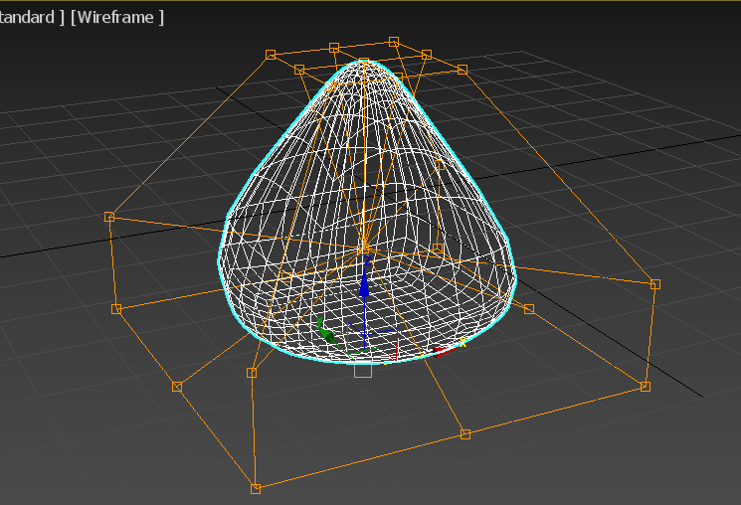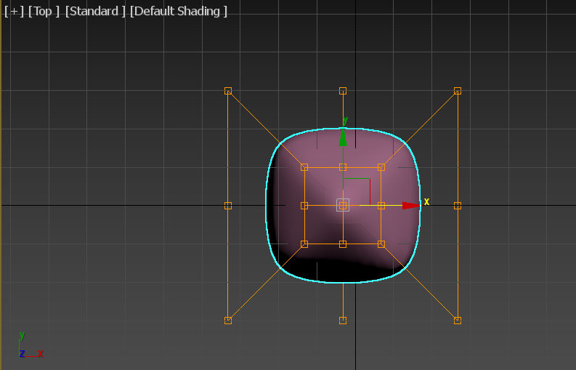

The control points are modified in the script in the following ways;

1. The top layer is shrunk to have the object point sharply at the top.
2. The bottom two layers are expanded in length and width to give a fatter bottom
3. The bottom layer is brought closer to the middle layer, and the top layer is raised to create a bulge at the bottom and a more “pointy” top.
4. The centre of the bottom layer along with the midpoints of the middle layer are brought to the centre of the object to create flat faces.

**NOTE:** There are many other scripts which generate object bodies. Here I have mostly covered the oblong script, and briefly discussed the pyramidal script, however these scripts all work similarly.

Some may use additional modifiers to have differing shapes, however the use of modifiers has also been outlined above as well.

**Script_MakeDefaultArms**

local arm= cylinder()  
arm.radius = 4.0  
arm.height = 25  
arm.heightsegs = 10

Creating cylinder named “arm” and assigning dimensions

addmodifier arm (bend angle: bendAngle)

Adding the “bend” modifier to the arm, and giving it an angle of bendedness depending on the input to the function.

arm.name = objName + "_Arm001"

For the purpose

branchPath= textureMainPath + "70_70_70" + ".png"  
arm.material = standardMaterial diffuseMap:(Bitmaptexture fileName: (branchPath)) showInViewport:true;

Assigning grey colour to arm, based on png texture

listOfArms = #(arm,instance arm,instance arm,instance arm)

Here we are creating an array called “listOfArms” and filling it with instances of the arm we created. These “instances” are essentially copies of the arm we just created and any modifiers we add to the original arm will be applied to all arms.

rotate listOfArms[1] (eulerangles 0 90 0)  
rotate listOfArms[2] (eulerangles 0 90 180)  
rotate listOfArms[3] (eulerangles -90 90 0)  
rotate listOfArms[4] (eulerangles 90 90 0)

Here, we’re using the rotate tool to position each of the four arms we just stored in the array on each face of the oblong rectangular shape we created.

listOfArms[1].pos = [5,0,0]  
listOfArms[2].pos = [-5,0,0]  
listOfArms[3].pos = [0,5,0]  
listOfArms[4].pos = [0,-5,0]

Here, we’re setting the x,y,coordinates of each arm. Notice how each arm is embedded into the body by the same amount.

return listOfArms

Output of script is the array containing all cylinders.

**Script_TakePics**

As previously mentioned, this script takes in two input floats;

1) angle above the object from which the photo is taken  
2) Distance to the object

qqArray.pivot = [0,0,0]

qqArray is the complete object body (with arms attached to main body). The pivot is set to zero, so that when we want to take photos of the object from different angles, we can rotate the object in the way we want.

circ = circle()  
circ.radius = abs (cos(anglevalue) * camdistance)  
circ.pos = [0,0,(sin(anglevalue) * camdistance)]

We create a circle that the camera will be bound to and ultimately denotes the camera’s position. Using trig we can calculate the camera’s x and z coordinates, for the specificied angle and distance we want.

cam = freeCamera()  
cam.type = #target  
cam.target.pos = [0,0,0]

We create a camera called cam and have it’s eyes centred on the object (cam.target.pos = [0,0,0]).

pc = path_constraint()  
pc.path = circ   
cam.position.controller = pc

A path constraint basically means that the camera’s position/movement is only limited to the lines defined to specific lines. In this case, the path constraint is set to the circle which means that the camera can only rotate around the object at a fixed height.

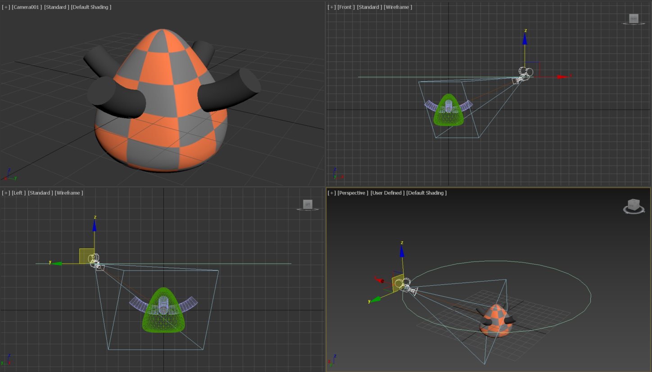

^This is what the camera would look like in the viewport

- -since camera is locked to path constraint of the circle, rotating circle will move camera  
viewport.setType #view_camera  
anglestring = anglevalue as string  
fileNameForPic = fileNameForPic + "pictures\\" + anglestring  
makeDir fileNameForPic

- -smoothhighlights is a render setting  
viewport.SetRenderLevel #smoothhighlights  
picturelocation = fileNameForPic + "\\" + anglestring + "_0deg_rotation_" + picname + ".jpg"  
render outputFile: (picturelocation) vfb: off outputSize: [1280,720]  
picturelocation = fileNameForPic + "\\" + anglestring + "_0deg_rotation_" + picname + ".png"  
render outputFile: (picturelocation) vfb: off outputSize: [1280,720]

- -rotate camera and take photos again  
rotate qqArray (eulerangles 0 0 45 )  
picturelocation = fileNameForPic + "\\" + anglestring + "_45deg_rotation_" + picname + ".jpg"  
render outputFile: (picturelocation) vfb: off outputSize: [1280,720]  
picturelocation = fileNameForPic + "\\" + anglestring + "_45deg_rotation_" + picname + ".png"

render outputFile: (picturelocation) vfb: off outputSize: [1280,720]  
rotate qqArray (eulerangles 0 0 -45)

Object is rendered to a jpg and png in both its native rotation and then rotated 45 degrees for another photo. The object is then rotated back to it’s original orientation.

delete circ  
delete cam

Circle path, and camera is deleted at the end of the function.

**Script_TakeVideo**

The takevideo script is extremely similar to the takepics. It takes the same two input arguments;

1. Angle above the object from which the video is taken
2. Distance to the object

I will emphasize here, the parts that are different.

light1 = Targetspot pos:[0,70,70] target:(targetObject pos:[0,0,0])  
light2 = Targetspot pos:[0,-70,70] target:(targetObject pos:[0,0,0])  
light3 = Targetspot pos:[0,-70,-70] target:(targetObject pos:[0,0,0])  
light4 = Targetspot pos:[0,70,-70] target:(targetObject pos:[0,0,0])  
light5 = Targetspot pos:[70,0,70] target:(targetObject pos:[0,0,0])  
light6 = Targetspot pos:[-70,0,70] target:(targetObject pos:[0,0,0])  
light7 = Targetspot pos:[-70,0,-70] target:(targetObject pos:[0,0,0])  
light8 = Targetspot pos:[70,0,-70] target:(targetObject pos:[0,0,0])

with animate on(at time 100 rotate qqArray (eulerangles 0 0 360))

viewport.SetRenderLevel #smoothhighlights  
picturelocation = fileNameForPic + "360_rotation" + picname + ".avi"  
render outputFile: (picturelocation) vfb: off outputSize: [640,360] fromframe: 0 toframe: 100

The TakeVideo script creates a set of 8 lights that equally illuminate the object from all angles. The object is then animated and this animation is saved as an avi file.

delete light1  
delete light2  
delete light3  
delete light4  
delete light5  
delete light6  
delete light7  
delete light8  
delete circ  
delete cam

The lights, circle and camera are then deleted after the video is taken.

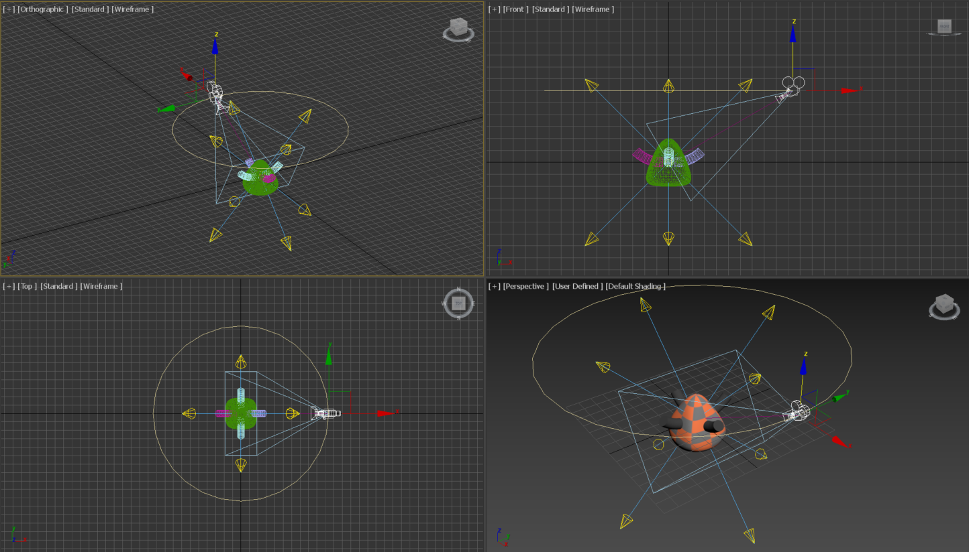

^This is what the set up would look like from the viewport.